WACE Exam Human Bio Study Notes
Nervous System
The Nervous System is the communication network and control centre of the body. It is also involved in maintaining a constant internal environment (homeostasis).
Divided into 2 main parts:
- Central Nervous System (CNS); consists of the brain and spinal cord
- Peripheral Nervous System (PNS); consists of the nerves connecting the CNS with receptors, muscles and glands.
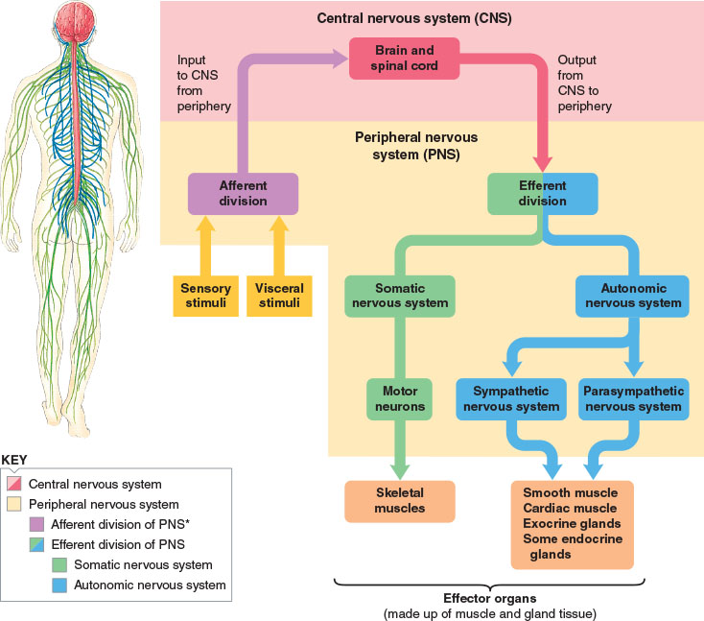
Neurons are the basic structural and functional units of the whole nervous system. All neurons consist of a cell body and 2 different types of extension from the cell (dendrites and axons).
Dendrites are fairly short extensions of the cytoplasm of the cell body. They carry nerve impulses into the cell body.
An axon carries nerve impulses away from the cell body. Most axons are covered with a layer of fatty material called the myelin sheath.
A nerve fibre is any long extension of a nerve cell.
Grey matter consists of unmyelinated nerve fibres.
White matter consists of myelinated nerve fibres.
Myelin sheath is formed by Schwann cells which coil around the axon, depositing myelin between the coils. At intervals along the axon are gaps in the myelin sheath called Nodes of Ranvier. The myelin sheath acts as an electrical insulator, protects the axon from damage, and increases the speed of nerve impulses along the axon (increases conduction velocity).
Neurilemma is the outer most layer of the Schwann cell that repairs damaged fibres.
Axon terminals are swellings at the ends of axons where neurotransmitters are released to carry the message across a synapse.
Types of Neurons:
- Sensory neurons; carry messages to the CNS
- Motor neurons; carry messages from the CNS
- Interneurons; carry messages between sensory and motor neurons
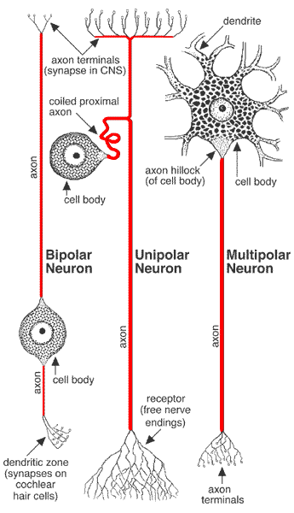
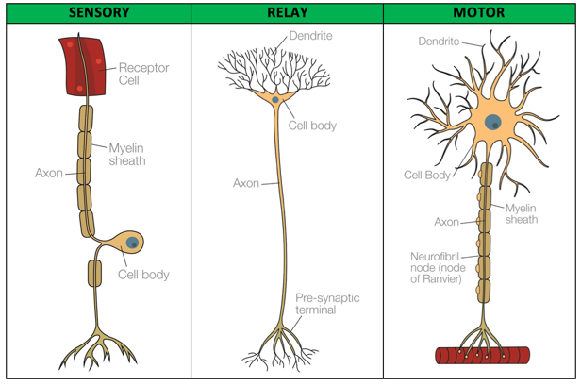
Structural Types of Neurons:
- Multipolar: 1 axon with multiple dendrites from cell body
- Bipolar: 1 axon and 1 dendrite
- Unipolar: 1 axon

Transmission of Nerve Impulses
A nerve impulse is an electrochemical change that travels along a neuron.
Nerve impulses in:
- Unmyelinated; 2m/s or 7km/h
- Myelinated; 18m/s to 140m/s or 65km/h to 500km/h
Nerve impulses are described as electrochemical as it involves a change in electrical voltage brought about by changes in the concentration of ions inside and outside the cell membrane of the neuron.
In biological systems, when the charges are separated by a membrane, this attraction is called a membrane potential. This occurs in all cells, but is particularly high in neurons.
When a neuron isn’t stimulated:
- Resting membrane potential is -70mv
- Extracellular fluid is high in Sodium (positive) and Chloride (negative) ions
- Intracellular fluid is low in Sodium ions and high in Potassium (positive) ions
- High concentration of sodium and chloride outside the cell means they tend to diffuse into the cell to equalise the concentration.
- However, the cell membrane is very permeable to potassium and chloride, and only slightly permeable to sodium.
- Therefore, potassium tends to diffuse out of the cell easily through protein channels, whereas sodium diffuses slowly into the cell.
- Loss of potassium and gain of chloride causes an imbalance of positive charges, causing the inside of the cell to have a slight negative charge, and the outside to have a positive charge.
- It is therefore said that the membrane is polarised.
When a neuron is stimulated:
- If a stimulus causing a change of 15mv or more is applied to a nerve fibre, the membrane becomes more permeable to sodium ions (due to the activation of voltage gated channels).
- The sodium ions move across the membrane and into the cell.
- This inwards movement of sodium ions is too great to be balanced by an outward movement of potassium ions, thus causing the membrane to be depolarised.
Voltage Gated Channels:
- Found embedded un the cell membrane of most cells, but are essential for the functioning of neurons.
- They are ‘opened’ by changes in the membrane potential (at least 15mv or more).
- The activation of voltage gated channels is achieved when a neuron is stimulated:
- Sensory neurons: are stimulated when receptors are stimulated
- Relay and motor neurons: are stimulated by neurotransmitters from other neurons at synapses
- Sodium and potassium voltage gated channels occur in neurons and muscle cells to trigger an action potential.
- Calcium voltage gated channels occur in axon terminals for the release of neurotransmitters.
- When voltage gated channels are opened up, sodium is able to pass through, making the cell membrane more permeable to sodium. Sodium ions then rapidly diffuse into the cell, depolarising it (i.e positive on the inside, negative on the outside).
- When the membrane potential reaches 30mv, the voltage gated channels close, stopping the rapid diffusion of sodium.
- The neuron is rapidly restored to its resting membrane potential, with positive charges outside the membrane and negative charges inside the membrane.
Returning the Neuron to its resting potential:
- Neuron is restored to its resting membrane potential via the sodium potassium pump mechanism.
- This involves special carrier proteins inside the membrane actively moving potassium inside the cell and sodium outside the cell via active transport.
The time between when the action potential is initiated to when the resting membrane potential is restored is called the refractory period. While this is occurring, this part of the nerve fibre cannot be stimulated to initiate another action potential.
Transmission across a Synapse:
A neuromuscular junction is a special type of synapse between the axon terminals of a motor neuron and a muscle cell.
A neuroglandular junction is a special type of synapse between the axon terminals of a motor neuron and a glandular cell.
- A gap exists between the axon terminal and post synaptic neuron. This is referred to as a synaptic cleft.
- Due to this gap, the impulse/action potential stops at the synapse and thus the message must be transmitted across the synaptic cleft by neurotransmitters.
- Different divisions of the nervous system have different neurotransmitters:
- Sympathetic; Noradrenaline
- Parasympathetic; Acetylcholine
- Somatic; Acetylcholine

- Action potential reaches presynaptic axon terminal and depolarises it.
- Calcium voltage gated channels are stimulated by this depolarisation and open.
- Calcium enters the cell and triggers exocytosis, resulting in the release of neurotransmitters.
- Neurotransmitter diffuses across the synaptic cleft.
- Neurotransmitters bind to neuroreceptors on the post synaptic cell.
- 15mv change in membrane potential is trigged in post synaptic neuron
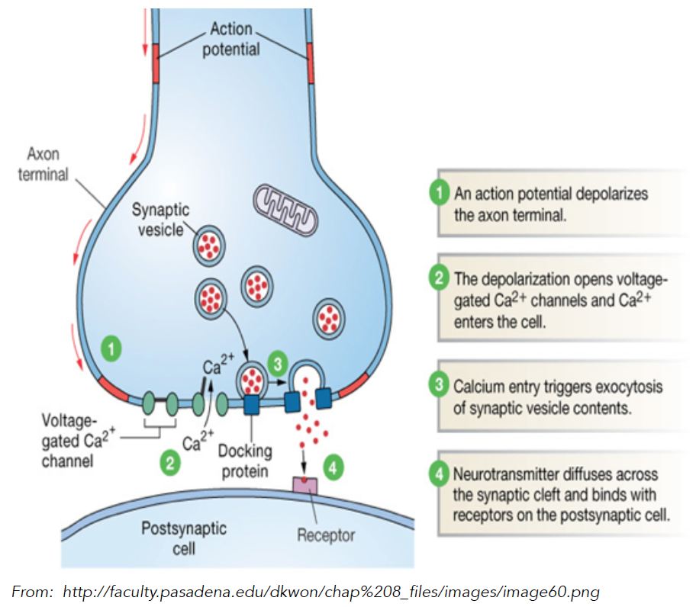

Conduction along Unmyelinated Fibres
- In unmyelinated nerve fibres, depolarisation of one area of the membrane causes a local current flow between neighbouring areas on the membrane.
- Current flow causes depolarisation adjacent to the site of the original stimulus.
- This process repeats itself along the length of the membrane so that the action potential moves along the membrane away from the point of stimulation.
- If the stimulus occurred in the middle of a fibre, impulses will travel in both directions along the fibre away from the point of stimulation (however this would be unusual in the human body).
- Each action potential generates another action potential just in front of it. Thus, an action potential does not travel along the nerve fibre; it is the message, or nerve impulse, that travels along the fibre.
- The nerve impulse is prevented from going backwards along the fibre by the refractory period.
Conduction along Myelinated Fibres
- In myelinated fibre, the nerve fibres are insulated from the extracellular fluid, except at the nodes of Ranvier. Because of this, ions cannot flow between the inside and the outside of the membrane, and an action potential cannot form.
- Action potential instead jumps from one node to the next due to the absence of the myelin sheath.
- Because of this salutatory conduction, impulses travel faster in myelinated fibres.
Effect of Chemicals on Transmission of Nerve Impulses
- Many chemicals influence the transmission of nerve impulses
- Most of these work y affecting transmission at the synapse or at a neuromuscular junction.
- Stimulants such as caffeine stimulate transmission at the synapse, while other drugs such as anaesthetics depress the transmission.
The Autonomic Nervous System
- ANS is responsible for the control of the body’s internal environment and is involved in many of the mechanisms that keep the internal environment constant.
- Operates under subconscious control and is regulated by groups of nerve cells in the medulla oblongata, hypothalamus and cerebral cortex.
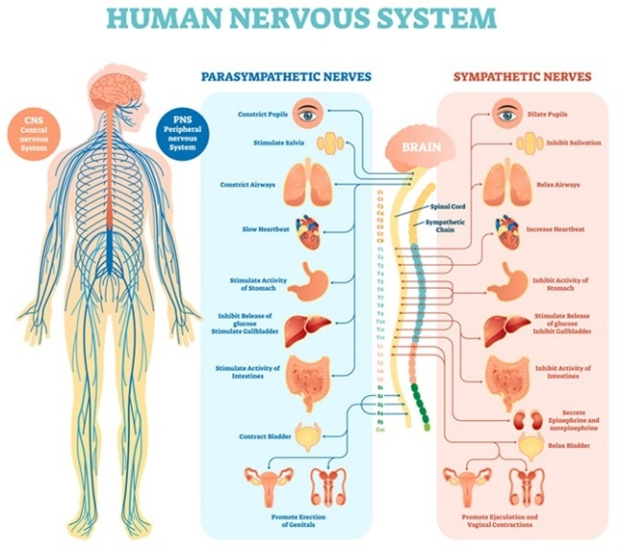
- Body functions regulated by the ANS include;
- Heart rate
- Blood pressure
- Body temperature
- Pupil diameter
- Air flow to lungs
- Defecation
- Urination
- Nerve fibres of the ANS make up part of the spinal and cranial nerves
- Carries impulses to heart muscle, involuntary muscle, and glands.
- 2 important differences between the autonomic and somatic divisions:
- Organs under ANS control receive 2 sets of nerve fibres (sympathetic and parasympathetic)
- SNS neurotransmitter is always acetylcholine, while ANS neurotransmitter is acetylcholine or noradrenaline
- Impulses from sympathetic and parasympathetic divisions have differing effects on organs and tissues.
- Can be said that the parasympathetic division maintains the body at rest, and the sympathetic prepares the body for strenuous activity.
- Parasympathetic nerve endings release acetylcholine, while sympathetic nerve endings release noradrenaline.
Fight or Flight Response
- In threatening situations, the balance between sympathetic and parasympathetic stimulation is upset, and the sympathetic becomes dominant.
- Situations that involve fear, anger, stress, danger or competition provoke the fight or flight response. These responses prepare the body for increased activity.
- Activation of the sympathetic division results in:
- Increased rate and force of heart contractions (results in increased blood pressure)
- Blood vessels dilate in organs involved in strenuous activity
- Blood vessels constrict in organs not involved in activity
- Lung airways dilate and rate and depth of breathing increases
- Blood glucose level rises due to conversion of glycogen to glucose by the liver
- Sweat gland secretion increases
- The adrenal medullae secretes adrenaline and noradrenaline which intensify and prolong these responses
The Central Nervous System
- Brain and spinal cord make up the CNS
- Nerves that carry messages to and from the CNS make up the PNS
Protection of the CNS
- 3 structures protect the CNS:
- Bone
- Outer most protective layer is bone. The cranium protects the brain and the vertebral canal (an opening in the vertebrae) protects the spinal cord.
- Meninges
- Inside the bones and covering the surface of the brain and spinal cord are 3 layers of protective tissue forming membranes called the meninges.
- Meninges cover the entire CNS.
- Outer meningeal layer is tough and fibrous; it sticks closely to bones.
- Middle meningeal layer is a loose mesh of fibres.
- Inner meningeal layer is extremely delicate and is highly vascularises. It sticks closely to the surface of the brain and spinal cord.
- Cerebrospinal Fluid (CSF)
- CSF occupies space between the middle and inner meningeal layers, and circulates through cavities in the brain and the central canal of the spinal cord.
- CSF is a clear, watery fluid containing few cells, and some glucose, protein, urea, and
- salts.
- It acts as a shock absorber, and supports the brain (the brain is suspended inside the cranium and floats in the CSF).
- It forms from the blood and circulates around the CNS, eventually re-entering as the blood capillaries. During circulation, it takes nutrients to cells of the brain and spinal cord, and carries away their wastes.
- Thus the CSF has 3 functions; protection, support and transport.
Comparison of Hormonal and Nervous Coordination
- Endocrine and nervous systems are involved in communication within the body.
- They don’t duplicate each other’s roles; they complement and reinforce each other.
- Differences between their actions include:
- Nervous responses are more rapid than hormonal ones as nerve impulses travel rapidly along nerve fibres, whilst hormones are transported by the blood stream.
- When a stimulus ceases, the nervous system stops generating nerve impulses and the response ceases almost immediately, whiles hormones are typically slower acting, and responses can last a considerable amount of time after a stimulus ceases.
- Nervous messages= electrochemical changes travelling along the neuron membrane. Endocrine messages= chemical(s) transported by the blood.
- Nerve impulses travel along a nerve fibre to a specific part of the body, and often influence one effector; hormones travel to all parts of the body and often affect multiple organs.
- Important similarities include:
- Some substances function as hormones and as neurotransmitters e.g. noradrenaline.
- Some hormones are secreted by neurons into the extracellular fluid e.g. oxytocin and adrenaline.
- Some hormones and neurotransmitters have the same effect on the same target cells e.g. noradrenaline and glucagon act on liver cells to cause glycogen to be broken down into glucose.
Structures of the Brain and their Functions
The Cerebrum
- Consists of outer surface of grey matter (known as the cerebral cortex), an inner layer of white matter, and deep inside is additional grey matter called the basal ganglia.
- Cerebral cortex is folded into convolutions which greatly increases its surface area.
- Convolutions are separated by sulci (shallow downfolds) or fissures (deep downfolds).
- Longitudinal fissure almost separates the cerebrum into 2 halves (cerebral hemisphere)
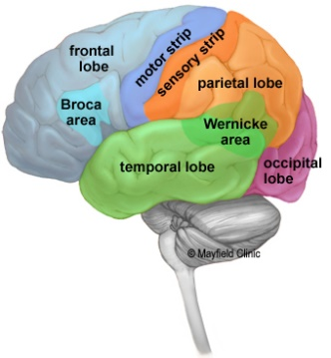
- Joining the hemispheres is white matter consisting of a large bundle of transverse fibres called the corpus callosum.
- Cerebral hemispheres can be subdivided into 4 lobes:
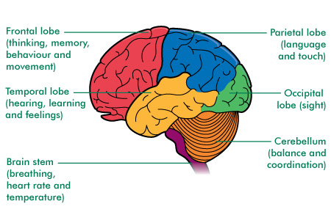
- Frontal
- Temporal
- Occipital
- Parietal
- Bundles of nerve fibres within the CNS are called tracts.
- 3 types of tracts occur in white matter between the cerebral cortex and basal ganglia:
- Tracts that connect areas of the cortex within the same hemisphere
- Tracts that carry impulses between the hemispheres
- Tracts that connect cortex to other parts of the brain or to the spinal cord.
Functions of the Cerebrum
- Cerebral cortex is involved in mental activities such as:
- Thinking
- Reasoning
- Learning
- Memory
- Intelligence
- Sense of responsibility
- Also concerned with perception of the senses, and the initiation and control of voluntary muscle contraction.
- 3 types of functional area in the cortex:
- Sensory areas: Receive and process nerve impulses from sense receptors
- Motor areas: Send impulses to muscles
- Association areas: Interpret information from the senses and make it useful (concerned with intellectual and emotional processes)
- Basal ganglia consists of groups of nerve cell fibres associated with control of skeletal muscles.
Corpus Callosum
- Wide band of nerve fibres that lies underneath the cerebrum.
- Nerve fibres cross from one hemisphere to the other and allows the two sides to communicate.
Cerebellum
- Lies under rear part of the cerebrum.
- Outer folded part is grey matter, inside is white matter.
- Exercises control over:
- Posture
- Balance
- Fine coordination of voluntary muscle movement
- To carry out these functions, the cerebellum has to receive sensory information from the inner ear and from stretch receptors in skeletal muscles.
- Functions of the cerebellum take place below conscious level.
- Impulses do not originate in the cerebellum, thus without it we could still move, but movements would be spasmodic, jerky, and uncontrolled.
Hypothalamus
- Located in the middle of the brain and is mostly concerned with homeostasis.
- Functions include the regulation of:
- The ANS
- Body temperature
- Food and water intake
- Circadian rhythm (patterns of waking and sleeping)
- Contraction of urinary bladder
- Emotional responses
- Secretion of hormones and coordination of endocrine system (regulates metabolism, growth, reproduction and responses to stress via the pituitary gland)
Medulla Oblongata
- Continuation of the spinal cord (extends just above where the spinal cord enters the skull)
- Medulla oblongata contains:
- Cardiac centre: Regulates rate and force of heart beat
- Respiratory centre: Controls rate and depth of breathing
- Vasomotor centre: Regulates diameter of blood vessels
Spinal Cord
- Cylindrical structure extending from foramen magnum to 2nd lumbar vertebrae.
- Composed of grey and white matter, with grey matter at the centre and white matter surrounding it.
- Central canal contains ascending tracts (sensory axons carrying impulses towards the brain), and descending tracts (motor axons carrying impulses away from the brain).
Chemical Messengers
Exocrine glands- Secrete into a duct that carries the secretion to the body surface or to one of the body cavities.
Endocrine glands- Secrete hormones into the extracellular fluid that surrounds the cells that make up the gland. Secretion then usually passes into the capillaries to be transported by the blood.
Hormones- secretion of endocrine glands. May be proteins, steroids or amines, and are transported throughout the body in the blood. A hormone may affect all the cells of the body, or only particular groups of cells (target cells), or particular organs (target organs).
Paracrines- Cells may communicate with other cells in the same tissue by secreting paracrines which diffuse to adjacent cells. They are secreted by all cells in a particular tissue and more through the extracellular fluid.
Protein and Amine based Hormones
- Attach to receptor proteins in the membrane of the target cell.
- Combination of the hormone with the receptor causes a secondary messenger substance to diffuse through the cell and activate particular enzymes. E.g. the hormone insulin binds to a receptor protein and this leads to an increase in glucose absorption by the cell.
- Receptor proteins are specific. Each type of receptor protein will bind with only one specific molecule.
- There is a limited number of receptor proteins in the membrane of each cell, therefore when each receptor is bound to a molecule, there can be no further increase in the rate of the cell’s activity.
- Different cells have different types and numbers of receptor proteins, this is why there is variation in the sensitivities of cells to hormones and other substances.
Steroid based Hormones
- Enter target cells and combine with a receptor protein inside the cell.
- Receptor may be on the mitochondria, other organelles, or in the nucleus.
- Hormone-receptor complex activates genes controlling the formation of particular proteins.
Effect of Hormones
- Change the functioning of cells by changing the type, activities, or quantities of proteins produced.
- Hormones exert influence by changing the activity of enzymes or by changing the concentration of enzymes.
- Hormones may:
- Activate certain genes in the nucleus so particular enzymes or structural proteins are produced.
- Change the shape or structure of an enzyme so it’s turned ‘on’ or ‘off’.
- Change rate of the production of an enzyme or structural protein by changing the rate of transcription or translation during protein production.
Enzyme Amplification
- One hormone does not cause the manufacture or activation of one enzyme.
- Hormones trigger a cascading effect in which the number of reacting molecules involved is increased hundreds or thousands of times for each step along the metabolic pathway.
- One hormone molecule could trigger the production of more than a billion enzyme molecules.
Hormone clearance
- Once a hormone has produced the desired effect, it must be turned off.
- Done by breaking down the target cells, but most are broken down in the liver and kidneys.
- The degraded hormones are then excreted either in the bile or in the urine.
Control of Hormone Secretions
- To maintain homeostasis, the amount of hormone produced by an endocrine gland must be closely regulated.
- Undersecretion or oversecretion will cause the body to function abnormally.
- Hormonal secretions are generally regulated by negative feedback systems (response produced by the secretion of the hormone is the opposite of the stimulus that caused the secretion), however some involve the nervous system through the release of regulating factors from the hypothalamus of the brain.
- Factors regulate the function of the pituitary gland.
- The hypothalamus can secrete releasing or inhibiting factors.
The Hypothalamus and the Pituitary Gland
- The hypothalamus is located at the base of the bran and it regulates many of the basic functions of the body such as body temperature, water balance and heart rate. Many of the functions of the hypothalamus are carried out by the pituitary gland.
- Pituitary gland (hypophysis) lies just under the hypothalamus and is joined to it by the infundibulum. Vital to the normal functioning of the body.
- Consists of anterior and posterior lobe, which function separately.
- Anterior lobe has no nerves connecting it to the hypothalamus, instead it is connected by a complex network of blood vessels.
- Posterior lobe isn’t a true gland as it does not secrete substances. Joined to the hypothalamus by nerve fibres that come from cell bodies, and pass through the infundibulum to the posterior lobe.
- Hypothalamus produces many different hormones. Some carried by blood to the anterior pituitary where they stimulate or inhibit the release of hormones made in the anterior lobe, while others pass along nerve fibres from the hypothalamus to the posterior lobe where they are ten secreted.
- Many pituitary hormones regulate the activity of other endocrine glands.
Anterior Pituitary Lobe (adenohypophysis)
- Releases a number of hormones that regulate a range of bodily activities.
- Secretions are controlled by releasing and inhibiting factors secreted by the hypothalamus. These factors are hormones because they are secreted into the extracellular fluid around the cells of the hypothalamus and are carried by the blood to the anterior pituitary lobe.

Table outlining hormones released by the Anterior Pituitary
Hormone | Effect
Gonadotropins | Affect gonads, ovaries and testes.
Follicle Stimulating Hormone (FSH) | A type of gonadotropin.  In females; it stimulates the development of the follicles that contain eggs.  In males; it stimulates the production and maturation of sperm in the testes.
Luteinising Hormone (LH) | A type of gonadotropin.  In females; it works with FSH to bring about ovulation and to form the corpus luteum after ovulation.  In males; it stimulates interstitial cells in the testes to secrete male sex hormones.
Growth Hormone (GH) | Also known as somatotropin.  Stimulates body growth and increases the rate at which amino acids are taken up by cells and built into proteins.  Secreted throughout life as it helps to maintain the size of organs once maturity is reached.
Thyroid Stimulating Hormone (TSH) | Also known as thyrotropin.  Stimulates the production and release of hormones from the thyroid gland.
Adrenocorticotropic Hormone (ACTH) | Also known as adrenocorticotropin. Controls production and release of some of the hormones from the cortex of the adrenal glands.
Prolactin (PRL) | Also known as lactogenic hormone.  Works with other hormones to initiate and maintain milk secretion in females.

Posterior Pituitary Lobe (neurohypophysis)
- Releases oxytocin and antidiuretic hormone (neither are manufactured in the posterior lobe).
- Both hormones are produced in special nerve cells in the hypothalamus (neurosecretory cells). These cells have long extensions that pass through the infundibulum to the posterior lobe.
- Hormones manufactured in the cells move down the extensions and are stored ready for release into the bloodstream.
- Release of hormones is triggered by nerve impulses initiated in the hypothalamus and conducted along cell extensions.
- Oxytocin stimulates contraction of the muscles of the uterus. It is released in large quantities during labour. Also stimulates contraction of cells in the mammary glands resulting in the release of milk during breastfeeding.
- Antidiuretic hormone (ADH) causes the kidneys to reabsorb water. This water is returned to the bloodstream. In this way, ADH helps to retain fluid within the body. At higher concentration, ADH can also cause constriction of arterioles.

Table outlining Endocrine Glands and their effect

Endocrine Gland | Location | Notes
Pineal Gland | Deep inside the brain. | Gradually decreases in size after puberty.  Secretes melatonin, which is involved in the regulation of sleep patterns.  Stimulated by darkness and inhibited by light.
Thyroid Gland | In the neck, below the larynx. | Consists of 2 lobes located either side of the trachea.  Main hormone secreted is thyroxine, which is continuously manufactured in the thyroid gland.  Controls body metabolism by regulating reactions in which complex molecules are broken down to release energy, and other reactions in which complex molecules are synthesises from simple ones.  Secreted in response to TSH from anterior lobe.
Parathyroid Gland | In the rear surface of the thyroid gland | Secretes parathyroid hormone (PTH) which controls calcium and phosphate levels in the blood.
Thymus | In the chest above the heart and behind the sternum | Secretes thymosins which influence the maturation of T-Lymphocyte cells.
Adrenal Medulla | Inner part of the adrenal gland | Secretes adrenaline and noradrenaline.  Adrenaline (epinephrine) helps to prepare the body for reaction to a threatening situation.  Noradrenaline (norepinephrine) increase rate and force of the heartbeat.
Adrenal Cortex | Outer part of the adrenal cortex | Secretes corticosteroids, the 2 main ones being:  Aldosterone; acts on the kidneys to reduce sodium and increase potassium in the urine.  Cortisol; promotes metabolism and helps repair damaged tissues.
Pancreas | Behind the stomach next to the duodenum | Both an exocrine and endocrine gland.  Exocrine part secretes digestive enzymes into the small intestine via the pancreatic duct.  Endocrine aspect carried out by the islets of Langerhans.
Islets of Langerhans | Clusters of special cells within the pancreas | Secretes 2 important hormones:  Insulin; reduces concentration of glucose in the blood by promoting the uptake of glucose to glycogen and fat. In skeletal muscles it causes the formation of glycogen from glucose, in fat storage tissue it causes glucose to be converted into fat. Level of secretion of insulin by the pancreas is determined by the amount of sugar in the blood, and is controlled by a negative feedback system.  Glucagon; acts in the opposite way to insulin. Works to increase blood sugar by promoting the breakdown of fat in the liver and in fat storage tissues.
Gonads | Are the testes and ovaries | They produce hormones as well as the sperm and the egg.  Androgens are male sex hormones produced by the testes, and are responsible for the development and maintenance of male sex characteristics.  Oestrogen and progesterone are female sex hormones produced by the ovaries. They stimulate the development and maintenance of female sexual characteristics. Together with gonadotropic hormones of the pituitary gland, they also regulate the menstrual cycle and are involved in the changes which take place during pregnancy.
Other Endocrine Tissues |  | The stomach and small intestine secrete hormones that coordinate exocrine glands of the digestive system.  Kidneys secrete hormones including erythropoietin (EPO), a hormone that stimulates the production of red blood cells by the bone marrow.  Heart secretes a hormone which helps to reduce blood pressure.  Placenta secretes a number of hormones during pregnancy that help to maintain pregnancy, stimulate development of the foetus, and stimulate the mothers mammary glands.

Detecting and Regulating Change
Receptors
- A structure that is able to detect a change in the body’s external or internal environment. Sometimes grouped together in a sense organ.
Thermoreceptors
- Able to respond to heat and cold.
- Thermoreceptors in skin inform the brain of changes in temperature outside the body (information is received by the hypothalamus and cerebrum).
- Temperature inside the body is monitored by thermoreceptors in the hypothalamus which detects the temperature of blood flowing through the brain.
Osmoreceptors
- Osmotic pressure is determined by concentration off substances dissolved in the blood plasma.
- Located in the hypothalamus and are sensitive to osmotic pressure.
- Respond to small changes in osmotic pressure and are able to stimulate the hypothalamus.
Chemoreceptors
- Stimulated by particular chemicals.
- Present in the nose and mouth.
- Internal chemoreceptors are sensitive to the composition of body fluids e.g. chemoreceptors in certain blood vessels are sensitive to the pH of blood and the concentration of O2 and CO2.
Touch Receptors
- Found mainly in the skin and there are a number of different types.
- Close to the surface of the skin= sensitive to light touches e.g fingertips.
- Nerve endings at the base of each hair follicle.
- Touch receptors close to skin surface and those attached to hairs adapt rapidly (after short time, we are no longer aware of the touch).
- Other receptors are located deeper in the skin and are sensitive to pressure and vibrations.
Pain Receptors (nociceptors)
- Stimulated by damage to the tissues.
- Especially concentrated in the skin and mucous membranes.
- Occur in most organs but not in the brain.
- Adapt little or not at all. Pain continues as long as the stimulus is present.
Reflexes
- Is a rapid, automatic response to a change in the internal or external environment.
- All reflexes have 4 important properties:
- A stimulus is required.
- It is involuntary.
- It is rapid (small number of neurons involved).
- It is stereotyped (occurs the same way each time).
- Some reflexes involve the unconscious parts of the brain, but most are coordinated by the spinal cord.
- When a nerve impulse comes into the spinal cord, the message is not necessarily carried up to the rain, the impulse may be passed to motor neurons.
- In these cases, the reflex is carried out by the spinal cord alone and is known as a spinal reflex and the pathway a nerve impulse follows in travelling from receptor to an effector is known as a reflex arc.
- A spinal reflex does not involve the brain and is thus involuntary.
- Impulses may be sent to the brain and so we become aware of what is happening, but this awareness does not occur until after the response has been initiated.
- A reflex arc has the following basic components:
- Receptor reacts to a change in the internal or external environment by initiating a nerve impulse in the sensory neuron.
- Sensory neuron carries impulses to the CNS.
- At least 1 synapse. Impulse may be passed directly to motor neuron or to 1 or more interneurons which direct the impulse to a motor neuron.
- Motor neuron carries impulse to an effector.
- Effector receives the impulse and carries out an appropriate response.
- Only after the response is the person consciously aware of the situation.
- Many reflexes protect the body from injury.
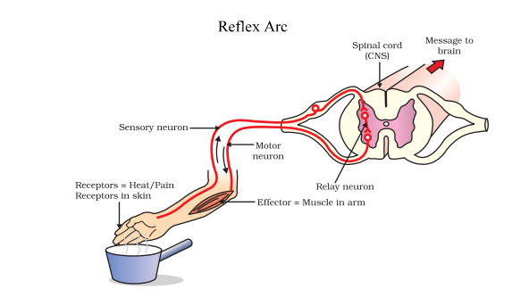

Learned Reflexes
- Protective reflexes are present from birth (e.g. blinking)
- Some complex motor patterns are learned and are called acquired reflexes. They are learned through constant repetition.
Immune System
Non-Specific Defences
- Work against all pathogens
External
- The skin:
- Provides a tough, waterproof physical barrier which prevents the entry of pathogens.
- Openings in the skin provide the only way pathogens can get in, unless there is a wound.
- Orifices have evolved some protection against entry by pathogens.
- Bacterial colonies live on the skin which usually block potentially harmful bacteria from becoming established.
- Sebum produced by oil glands has antibiotic properties.
- Sweat is acidic and contains salt and lysozyme which inhibit bacterial growth.
Protective Reflexes
Sneezing- The expulsion of air forces out irritating particles, gases and microbes from the nasal cavity and mouth.
Coughing- Expulsion of air from the trachea and bronchi forces up mucus containing irritating particles, gases and microbes to the back of the throat where it’s swallowed.
Cilia- Push mucus containing pathogens up through the bronchioles, bronchi and trachea to the back of the throat where it is swallowed.
Vomiting- Expels the stomach’s contents when it contains toxins from pathogens.
Diarrhoea- Pathogens irritate the intestine which contracts and expels pathogens in the faeces (before water has been reabsorbed).
Rapid Onset Fever
- White blood cells attack the pathogen, often breaking it up.
- In doing so the pathogen may release chemicals called pyrogens.
- Pyrogen enters the blood and the hypothalamus is stimulated to increase the set point for body temperature, after detecting their presence.
Internal Non-specific defences
Phagocytes: Cells that can engulf and digest micro-organisms and cell debris
Leucocytes: White blood cells. Play a part in phagocytosis. Are able to leave the blood capillaries and migrate through the tissues to places of infection or injury. Some secrete substances that destroy bacteria before engulfing them, where as other engulf live bacteria and digest them.
Macrophages: Large phagocytic cells that develop from some leucocytes. Some are wandering cells while others are fixed. They either engulf and digest micro-organisms, or release substances and destroy them.
Inflammatory Response
- Inflammation is a response to any damage to tissues.
- The purpose of inflammation is to:
- Reduce the spread of pathogens, destroy them, and prevent the entry of additional pathogens.
- Remove damaged tissue and cell debris.
- Begin repair of damaged tissue
4 signs of inflammation
- Redness
- Swelling
- Heat
- Pain
Damage to tissues stimulates the inflammatory response:
- When stimulated by mechanical damage or by local chemical changed, mast cells release histamine, heparin and other substances into tissue fluid. Mast cells stimulate and coordinate inflammation by releasing chemicals.
- Histamine increases blood flow through the area and causes the walls of the blood capillaries to become more permeable. Increase blood flow causes heat and redness, and the escape of fluid from blood causes swelling.
- Heparin prevents clotting. A clot of fluid around the damaged area does form and slows the spread of the pathogen into healthy tissue.
- Chemicals released by mast cells attract phagocytes.
- Abnormal conditions in the tissue stimulate pain receptors.
- Phagocytes filled with bacteria, debris and dead cells begin to die. Dead phagocytes and tissue fluid form pus.
- New cells are produced by mitosis and repair of the damage tissue takes place.
Fever
- Change in body temperature is due to a resetting of the body’s thermostat, controlled by the hypothalamus.
- Fever is beneficial to a point. High body temperature is believed to inhibit the growth of some bacteria and viruses. In addition, heat speeds the rate of chemical reactions, which may in turn help body cells repair themselves more quickly during disease.
- Fever can be harmful if it goes too high.
- Resetting of the body’s thermostat is thought to be due to pyrogens.
Lymphatic System and Non-Specific Defence
Lymphatic system consists of:
- Network of Lymph capillaries joined to larger lymph vessels.
- Lymph nodes
- Main function is to collect escaped fluid from blood capillaries and return it to the circulatory system. In addition it is an important part of the body’s internal defence against pathogenic organisms.
- Lymph entering the lymph nodes contains cell debris, foreign particles, and micro-organisms that have penetrated the body’s external defences. Some of these micro-organisms may be pathogenic and, if not destroyed, could cause disease.
- Lymph nodes occur at intervals along the lymphatic vessels. Each contain masses of lymphoid tissue, which have criss-crossed fibres. Larger particles become trapped in the mesh work of fibres as the lymph flows through the spaces.
- Macrophages destroy trapped particles and ingest them by phagocytosis. Projections surround the particle and take it into the cell where it is destroyed by enzymes.
- When infections occur, formations of lymphocytes increases and lymph nodes become swollen and sore.
The Immune Response
- A homeostatic mechanism
- 2 parts:
- Humoral response (antibody mediated); involved the production of special proteins called antibodies which circulate around the body and attacking invading agents.
- Cell mediated response; involves formation of special lymphocytes that destroy invading agents.
- Both involve lymphoid tissue
- Most lymphoid tissue is in the lymph nodes, but it also occurs in other parts of the body such as the spleen, thymus and tonsils.
- Much of lymphoid tissue is composed of B-cells and T-cells.
- B-cells provide anti-body mediated immunity, while T-cells provide cell mediated immunity. Both cells are produced in the bone marrow.
- Half the cells produced in the bone marrow go to the thymus, where they mature into T-Cells.
- The other half mature in the bone marrow and become B-cells.
Antibodies
- An antibody is a specialised protein that is produced in response to a non-self-antigen.
- Antibodies belong to a group of proteins known as immunoglobulins.
- The antibody produced in response to an antigen can combine with that antigen to form an antigen-antibody complex.
- The active site on the antigen and the active part of the antibody ‘fit’ together. Each antibody can only combine with one particular antigen.
Antibody Mediated Immunity
- Humoral response involves the production and release of antibodies into the blood and lymph.
- Provides resistance to viruses, bacteria and bacterial toxins before these micro-organisms or substances enter the body’s cells.
- When an antigen activates b-cells, they enlarge and divide into a group of cells called a clone. Most become plasma cells, which secrete specific antibodies capable of attaching to the active site of the antigen.
- B-cells of the clone that did not differentiate into plasma cells remain as memory cells.
- Memory cells spread to all body tissues to allow the response to occur more rapidly should the antigen enter the body again.
- First exposure to an antigen is the primary response. The body’s immune system usually responds fairly slowly, often taking several days to build up large enough amounts of antibodies.
- It takes time for B-cells to multiply and differentiate into plasma cells.
- As the plasma cells begin to secrete antibodies, the level of that particular antibody in the blood plasma rises.
- Once it reaches a peak, it begins to decline. However, the primary response leaves the immune system with a memory of that particular antigen.
- A second exposure to the same antigen has a much faster response because of the activity of memory cells.
- With this secondary response, plasma cells are able to form very quickly, with antibody levels in the blood plasma rising rapidly.
Antibodies may:
- Combine with foreign enzymes or bacterial toxins, or inactivate them by inhibiting reactions with other cells or compounds.
- Bind to the surface of viruses and prevent the viruses from entering cells.
- Coat bacteria so they are more easily consumed by phagocytes.
- Cause particles such as bacteria, viruses or foreign blood cells to clump together (agglutination).
- Dissolve organisms.
- React with soluble substances to make them insoluble and thus more easily consumed by phagocytes.
Cell Mediated Immunity
- Provides resistance to the intracellular phase of bacterial and viral infections.
- These pathogens specialise in invading and replicating inside the host cells.
- Also important in providing resistance to fungi and parasites and involved in the rejection of transplants of foreign tissues.
- T-lymphocytes are responsible for cellular immunity.
- Occur in the same lymphoid tissue as B-cells but occupy different areas of the tissue.
- Thousands of T-cells, with each responding to one particular antigen.
- When a foreign antigen enters the body, the particular type of T-cells that are specifically programmed for that antigen become sensitised.
- Only occurs after b-cell or macrophage encounters the foreign antigen, travel to the nearest lymph node and presents it to the t-cell.
- Sensitised T cells enlarge and divide, each giving rise to a clone, a group of identical t-cells.
- Some of the cells remain in the lymphoid tissue as memory cells.
- The T cells that do not become memory cells develop further, producing 3 different types of T cell:
- Killer T-cells migrate to the site of infection and deal with the invading antigen. Attach to the invading cells and secrete a substance that will destroy the antigen.
- Helper T-cells play an important role in both humoral and cellular immunity. They secrete a number of substance that; cause lymphocytes at the infection site to become sensitised, thus intensifying the response, and attract macrophages to the place of infection so that the macrophages can destroy the antigens by phagocytosis.
- Suppressor T-cells act when the immune activity becomes excessive or the infection has been dealt with successfully. They release substances that inhibit T and B cell activity, slowing down the immune response.
Homeostasis
- The process of keeping the environment inside the body fairly constant. Maintenance of optimum condition for cell functioning is part of homeostasis.
- Homeostatic mechanisms help us to be independent of our external environment.
- Important aspects of the internal environment that the body needs to regulate includes:
- Core body temperature.
- pH and concentration of dissolved substances in body fluids.
- Concentration of glucose in blood.
- Concentration of O2 and CO22 in blood and body fluids.
- Blood pressure.
- Concentration of metabolic wastes.
- Maintenance of steady state does not mean nothing changes, instead there is a dynamic equilibrium in which the output and input of materials and energy are balanced.
- To maintain homeostasis, the body must be able to sense changes in the internal and external environment and compensate for those changes.
- Nervous and endocrine systems are the main sensory and controlling body systems, and in the case of homeostasis, they operate through feedback systems.
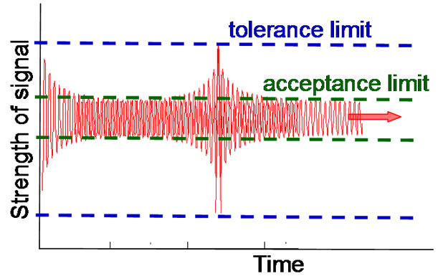
Tolerance Limits
- Upper and lower limits to a range of factors.
- Within these limits the body functions normally.
- A rise above or a fall below the normal range means that the individuals tolerance limits have been exceeded and dysfunction will start to occur.

Feedback Systems
- circular system in which the body responds to a change or stimulus.
- Has a number of common features:
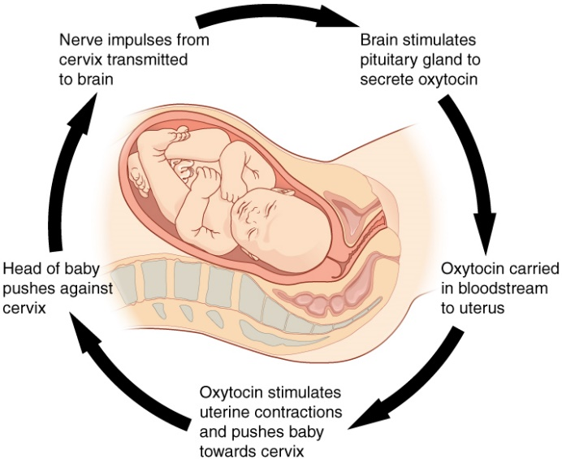
- Stimulus (change that causes the system to operate).
- Receptor (detects change)
- Modulator (control centre responsible for processing information received by receptor and sending information to effector).
- Effectors (carries out response).
- Feedback (achieved by response).
- Negative feedback is when the response has the effect of reducing or eliminating the response which caused it. Occurs most frequently.
- Positive feedback is when the response to a stimulus reinforces and intensifies the stimulus. Rarely occurs. 2 examples include blood clotting and child birth.
Thermoregulation
- Maintaining the balance between heat production and heat loss.
- Heat is produced from body processes (metabolism), especially respiration of liver and muscle cells, and heat is gained from surroundings by conduction and radiation.
- Heat is lost by radiation, conduction and convection to surroundings, and is also lost by evaporation of water from skin and lungs.

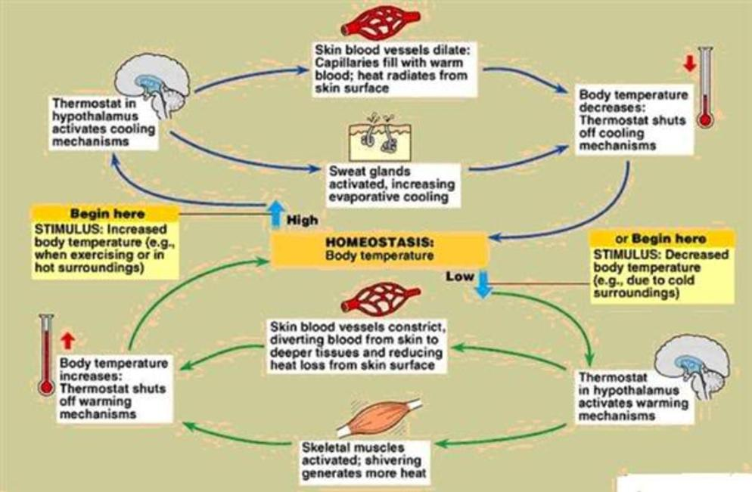
Heat Production
- Carbohydrates, proteins and lipids contain energy in chemical bonds. In the process of cellular respiration (in which food is oxidised in the cell), energy is released.
- The rate at which energy is released by the breakdown of food is called the metabolic rate.
- Stimulation of sympathetic nerves releases noradrenaline from the nerve endings (which increases metabolic activity of cells).
- Strong sympathetic stimulation may cause dramatic increases in the metabolic rate (but usually only for a few minutes).
- Most of the energy released is in the form of heat.
Temperature Receptors
- Peripheral thermoreceptors are found in the skin and in some mucous membranes.
- Central thermoreceptors are located in the hypothalamus.
- Peripheral thermoreceptors provide the hypothalamus with information about the external environment through the presence of cold and heat receptors.
- When cold receptors are stimulated, hypothalamus receives information and initiates heat conservation and heat production mechanisms.
- When heat receptors are stimulated, mechanisms operate to reduce heat production ad increase heat loss.
The Skin and Temperature Regulation
- Diameter of blood vessels to the skin is controlled by the autonomic nerves, which can act to increase or decrease the flow of blood near the surface of the skin, thereby increasing or decreasing the rate of heat loss.
- Autonomic adjustments to skin blood flow keep the core body temperature constant in moderate conditions.
- Sweating is the active secretion of fluid by the sweat glands and the periodic contraction of cells surrounding the ducts to pump the sweat to the skin surface.
- Production and transport of sweat to the skin surface is stimulated by sympathetic nerves.
- Sweat is water containing dissolved substances (primarily sodium chloride, along with small amounts of urea, lactic acid and potassium ions).
- Evaporation of sweat from skin has a cooling effect as heat is removed from the skin when liquid sweat changes into vapour.
Preventing Body Temperature from Falling
- Cold receptors in the skin send impulses to the hypothalamus which then sends out impulses aimed at reducing heat loss and increasing heat production.
- Body can respond by physiological changes and behavioural chanes.
- Physiological response:
- Vasoconstriction
- Impulses from hypothalamus stimulate sympathetic nerves that cause blood vessels in the skin to constrict.
- This decreases the flow of warm blood to the skin from the internal organs, thus decreasing the transfer of heat from internal body organs to the skin.
- Skin becomes cooler because there is less warm blood flowing through it, thus less heat is lost from the body surface.
- Stimulation of adrenal medulla
- Stimulated by the hypothalamus via sympathetic nerves.
- Medulla secretes adrenalin and noradrenaline into the blood which brings about an increase in cellular metabolism, leading to an increase in heat production.
- Shivering
- Hypothalamus stimulates parts of the brain responsible for increasing muscle tone.
- Increase in muscle tone leads to oscillating, rhythmic muscle tremors to occur at a rate of around 10-20 per second.
- Shivering is under primary control of the hypothalamus, but conscious input from the cerebral cortex can suppress the urge to shiver.
- Increase in thyroxine production
- Hypothalamus stimulates anterior pituitary to secrete TSH which causes the thyroid gland to secrete thyroxine into the blood.
- Increased levels of thyroxine increase metabolic rate.
- This response is slow to have an effect, but it is much longer lasting.
Preventing Body Temperature from Rising
- Physiological changes include:
- Vasodilation
- Blood vessels increase blood flow to the skin.
- Greater loss of heat through radiation and convection.
- Sweating
- Cooling effect of sweating is only effective in fairly dry environments.
- Only occurs above temperatures of 28 degrees Celsius.
- Reduced thyroxine production
- Decrease in metabolic rate is bought about by reduction in the secretion of thyroxine.
Control of Thermoregulation
- Hypothalamus exercises control over various mechanisms involved in thermoregulation.
- It monitors the temperature of the blood and receives impulses from peripheral thermoreceptors.
- Occurs in a negative feedback loop.
Regulation of the Composition of Body Fluids
- Fluid gain must = fluid loss if the composition of body fluids is to be kept constant.
- Most body fluid is obtained by liquids or food, but a small amount is obtained as a by-product of chemical reactions (metabolic water).
- Fluids are lost by the kidneys through the skin, from the surface of the lungs, and from the alimentary canal.
Excretion
- The removal of waste products of metabolism from the body.
- Lungs involved in excretion of CO2. Some water is lost from the lungs as water vapour we exhale.
- Sweat glands in the skin secrete water containing by-products of metabolism such as salts and lactic acid.
- Alimentary canal passes out bile pigments that entered the small intestine with the bile. The pigments are the breakdown products of haemoglobin from red blood cells and they leave the body via faeces.
- Kidneys are the principal excretory organ. They are responsible for maintaining a constant concentration of materials in the body fluids. An important waste removed by the kidneys is urea, which is produced in the liver during the breakdown of proteins.

The Kidneys
- Only water loss from the kidneys can be regulated to achieve a constant concentration of dissolved substances in the body fluids.
- The nephron is the functional unit of the kidney.
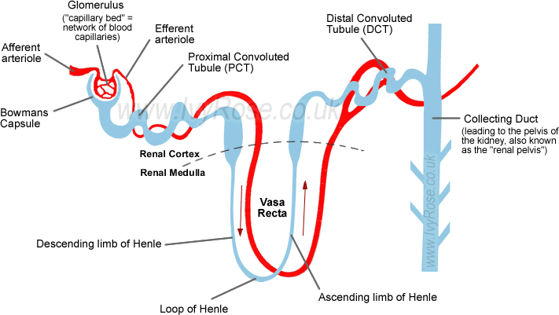
Control of Water Los by the Kidneys
- Volume and composition of urine produced by the kidneys is dependent on the concentration of water in the body fluids.
- Reabsorption occurs at the proximal convoluted tubule and loop of Henle via osmosis.
- Reabsorption at distal convoluted tubule and collecting duct occurs via active reabsorption.
- Levels of active reabsorption are controlled by antidiuretic hormone (ADH), which is produced by the hypothalamus and released by the posterior pituitary.
- High concentration of ADH= tubules very permeable to water, therefore water is able to leave the tubule and enter the surrounding capillary network.
- Low concentration of ADH= tubules not very permeable to water and little is reabsorbed.
- In addition to ADH, aldosterone regulates water output.
- Secreted by the adrenal cortex, it acts on the kidney tubules to increase the reabsorption of salt into the bloodstream, and increases the amount of potassium excreted in the urine.
- Water is absorbed along with sodium (salt), thus aldosterone has a role in regulating water content of the body.
- Increased aldosterone secretion has the indirect effect of increasing blood pressure.
Regulating Water Intake
- Water is continually lost from the body in sweat, urine, faeces and exhaled breath.
- As water is lost from the blood, the plasma becomes more concentrated (low water content), and a higher osmotic pressure.
- As a result, water moves from intercellular fluid to the plasma by osmosis.
- Now intercellular fluid is more concentrated and water diffuses out of the cells resulting in the cells shrinking (becoming flaccid) due to dehydration.
- Steps to restore balance of water:
- As water is lost from various body fluids, plasma volume decreases and osmotic pressure increases.
- Osmoreceptors in the thirst centre of the hypothalamus detect rising osmotic pressure of the blood. Other stimuli such as dry mouth is also involved.
- Stimulation of the thirst centre causes the person to consciously feel thirsty.
- Conscious feeling of thirst stimulates the person to drink.
- Fluid is consumed and is absorbed into plasma from the alimentary canal.
- As blood circulates through the body, it enables the intercellular and intracellular fluids to return to normal osmotic pressure.
- After drinking, the thirst centre is no longer stimulated, and the desire to take in water ceases.
Homeostasis of Blood Sugar and Gas Concentration
Regulation of Blood Sugar
- Blood sugar= the amount of glucose in the blood.
- Energy is released from glucose molecules by cellular respiration.
- Glucose is store as glycogen.
- Glycogen is the form in which carbohydrate is stored in the body (storage is mainly in the liver and muscle cells).
- Pancreas and adrenal glands secrete hormones that affect the level of glucose in the blood.
- Liver stores glycogen from which glucose can be made and added to the blood; or glucose can be removed from the blood and stored as glycogen.
Role of the Liver
- Able to convert glucose into glycogen for storage, or glycogen to glucose for release into the blood.
- Livers blood supply comes through the hepatic portal vein, which brings blood directly from the stomach, spleen, pancreas and small and large intestines.
- The hepatic portal vein carries the glucose to the liver via the blood, where a number of things can happen:
- Glucose may be removed from the blood to provide energy for liver functioning.
- Glucose may be removed and converted to glycogen for storage.
- Glucose may continue to circulate in the blood.
- Glucose in excess is converted into fat for long term storage.
- Glycogenesis (conversion of glucose to glycogen) is stimulated by insulin.
- Glycogenolysis (conversion of glycogen to glucose) is stimulated by glucagon.
Role of Pancreas
- Within the pancreas are clusters of hormone secreting cells known as the Islets of Langerhans.
- 2 types of cells in the Islets of Langerhans:
- Alpha cells; secrete glucagon.
- Beta cells; secrete insulin.
- Insulin from beta cells decreases blood sugar levels by:
- Accelerating the transport of glucose from the blood into cells.
- Accelerating the conversion of glucose into glycogen.
- Stimulating the conversion of glucose in fat in adipose tissue.
- By causing an increase in protein synthesis in some cells.
- When blood sugar levels rise above normal, chemoreceptors in beta cells of the Islets of Langerhans stimulate the secretion of insulin.
- As the level of sugar decreases, cells are no longer stimulated and production is reduced.
- Glucagon from the alpha cells causes an increase in blood sugar. It does this by:
- Stimulating glycogenolysis in the liver.
- Stimulating gluconeogenesis; the formation of sugar molecules from fats and amino acids.
- Mildly stimulating the breakdown of proteins.
Role of Adrenal Glands
- Outer= Cortex, Inner= Medulla.
- Glucocorticoids secreted by the cortex, adrenaline and noradrenaline are secreted by the medulla.
- Adrenal cortex is stimulated to secrete glucocorticoids by adrenocorticotropic hormone from the anterior pituitary.
- Glucocorticoids regulate carbohydrate metabolism by ensuring enough energy is provided to the cells, subsequently stimulating glycogenolysis.
- Also increase the rate at which amino acids are removed from cells and transported to the liver.
- Some of these amino acids may be used in gluconeogenesis if glycogen and fat levels are low.
- Glucocorticoids also promote mobilisation of fatty acids from adipose tissue, allowing muscle cells to shift from glucose to fatty acids for their metabolic energy.
- Medulla synthesises adrenaline and noradrenaline which produce the same effect as those bough about by the sympathetic nerves of the autonomic nervous system.
- In particular, adrenaline elevates blood glucose levels and in doing so counteracts the effects of insulin. Stimulates production of lactic acid from glycogen in muscle cells, and the lactic acid can then be used by the liver to manufacture glucose.
Regulation of Gas Concentrations
- All cells need a continuous supply of O2 for respiration; all cells produce CO2 as a waste product of respiration.
- Therefore it is crucial that the levels of these gases in the body are regulated.
- Respiratory system is responsible for intake of O2 and excretion of CO2.
- Lungs are the organs in which the exchange of CO2 for O2 occurs.
- Changes in breathing therefore change the amount of O2 in and Co2 out.
- Circulatory system carries O2 from the lungs to the cells, and takes CO2 to lungs for excretion.
Control of Breathing
- Muscles that cause air to move in and out of the lungs are the diaphragm and intercostal muscles.
- These are skeletal muscles and require stimulation from nerve impulses to initiate contraction.
- Diaphragm stimulated by phrenic nerve, intercostal muscles stimulate by intercostal nerves. These are spinal nerves and originate in the spinal cord at the level of the neck and throat.
- Nerve impulses to diaphragm and intercostal muscles are controlled by the respiratory centre in the medulla oblongata.
- 2 regions within the respiratory centre: one which controls expiration, and one which controls inspiration.
- To coordinate breathing, messages must pass back and forth between the neurons in these 2 regions.
- Both O2 and CO2 are carried in the blood and affect breathing rate.
- In addition, concentration of CO2 in the blood plasma affects the concentration of hydrogen ions.
- When CO2 dissolves in H2O it forms carbonic acid, which breaks down to form hydrogen ions and bicarbonate ions.
- O2, CO2, and H, all have some effect on the regulation of breathing activity.
Oxygen Concentration
- As oxygen is consumed by cells, its concentration in the blood begins to fall.
- If concentration falls below normal while other factors remain constant, breathing rate increases.
- Within the normal range of concentration, its effect on breathing rate is only slight.
- If concentration falls to very low levels, only then does O2 concentration have a major stimulatory effect. Thus under normal circumstances, O2 plays little part in the regulation of breathing.
- Groups of cells within the walls of the aorta and carotid arteries are sensitive to changes in concentration of O2 in blood plasma.
- These groups of peripheral chemoreceptors are known as aortic and carotid bodies. Also central chemoreceptors in the medulla oblongata.
- Large decrease in O2 concentration stimulates chemoreceptors and nerve impulses are transmitted to the respiratory centre.
- Impulses stimulate transmission of messages to diaphragm and intercostal muscles, thus breathing rate increases.
Carbon Dioxide Concentration
- Concentration of CO2 in blood plasma is a major factor in the regulation of breathing rate.
- Relatively small increase in CO2 concentration is enough to cause a marked increase in the rate of breathing.
- Increase in CO2 results in increase of H ions.
- Increase in concentration of these chemicals in the blood stimulates central and peripheral chemoreceptors.
- These in turn transmit nerve impulses to the respiratory centre resulting in an increase in breathing rate.
- Chemoreceptors most sensitive to changes in the concentration of CO2 in the plasma are found in the medulla oblongata.
- Neurons making up these central chemoreceptors are separate from, but communicate with, the respiratory centre. They are responsible for 70-80% of the increase in breathing rate, but this response takes several minutes.
- Immediate increase in breathing rate following an increase in CO2 concentration in the blood plasma is produced by the aortic and carotid bodies, which are stimulated by an increase in H ion concentration.
Hydrogen Ion Concentration
- As H ion concentration increases, pH decreases, causing an increase in breathing rate.
- Decrease in pH directly stimulated chemoreceptors in the aortic and carotid bodies, which then transmit impulses to the respiratory centre, subsequently increasing breathing rate.
Voluntary Control of Breathing
- Humans are able to voluntarily control rate and depth of breathing (e.g speech).
- Voluntary control comes via connections from the cerebral cortex to descending tracts in the spinal cord.
- Voluntary control bypasses the respiratory centre in the medulla oblongata.
- Is a protective device.
- Cannot stop breathing forever- build-up of CO2 in plasma stimulates the inspiratory centre to send impulses to the diaphragm via the phrenic nerve, and the intercostal muscles via the intercostal nerve, which forces breathing.
- Rapid, deep breathing can provide more oxygen than required, and remove more CO2 than necessary (hyperventilation).
- Usually corrects itself as a decrease in CO2 concentration means chemoreceptors aren’t stimulated and there is no urge to breath.
- Dangerous practice is hyperventilation before swimming.
- Allows a person to stay under water longer due to loss of CO2.
- Individual may lose consciousness from lack of oxygen to the brain as they don’t feel the urge to breath (as chemoreceptors aren’t stimulated).
- Many drowning deaths in Australia have been the direct result of hyperventilation.
Exercise and Breathing
- During exercise, contracting muscle cells require large amounts of O2 and produce large amounts of CO2.
- Increased demand for gas exchange results in an increase in rate and depth of breathing.
- Same factors influencing breathing at rest appear to be involved in this increase.
Heart Rate and Blood Pressure
- Heart pumps the blood that carries O2 to the tissues and transports CO2 from the tissues.
- Output of blood from the heart is therefore crucial to maintaining homeostasis.
- Heart rate= beats per minute.
- Stroke volume= volume of blood forced from the heart with each contraction.
- Cardiac output= amount of blood leaving the heart every minute (heart rate x stroke volume).
- Blood pressure is the force with which the blood passes the walls of the blood vessels.
- Blood pressure depends on
- Cardiac output
- Diameter of blood vessels
- Blood pressure is closely related to cardiac output: any increase in heart rate and force of contraction increase blood pressure, and vice versa.
- Factors that affect the diameter of the blood vessels also act to control blood pressure.
Regulation of Heart
- Bundles of specialised nerve cells controlling the heart’s activity are called the sinoatrial node and atrioventricular node.
- SA node= pacemaker (responsible for rhythmical contraction of the heart).
- SA node is located in the wall of the right atrium below the superior vena cava.
- SA node initiates each heartbeat with an impulse that spreads out over both Atria causing them to contract.
- As the impulse spreads over the atria, it eventually reaches the AV nod, which is situated between 2 atria near the atrioventricular valves.
- Although the SA node can stimulate the heartbeat on its own, its activity is influenced by the ANS.
- ANS has neurons that carry impulses to the SA and AV nodes, as well as to the atria of the heart.
- These neurons bring impulses from the medulla oblongata (cardiac centre).
- ANS control of the heart is the result of balancing the opposing influences of the sympathetic neurons and the parasympathetic neurons.
- Whenever one division is stimulated, the activity of the other is inhibited.
- Some receptors involved in this task are the chemoreceptors in the aortic and carotid bodies and in the medulla oblongata. Although they are more important in controlling respiration, they do influence heart rate.
- Any increase in CO2 concentrations or decrease in pH influences the cardiac centre to increase cardiac output.
Changes to Blood Flow during Exercise
- To maintain the activity of the muscle cells during exercise, a large increase in blood flow is required to ensure an adequate supply of O2 and nutrients and to remove the CO2 and heat produced.
- During exercise it is the contracting muscles that require extra blood flow. Other organs do not need extra O2 and nutrients and do not release extra CO2.
- To ensure that blood supply to the muscles is increased, blood vessels in internal organs such as the alimentary canal constrict.
- At the same time there is a dilation of blood vessels in the muscles. Blood is directed away from organs that do not require increased blood flow to the contracting muscles that do require more blood flow.
Disruptions to Homeostasis
Diabetes
- A hormonal problem causing serious disruptions o homeostasis.
- A person with diabetes has an abnormally high blood glucose level (hyperglycaemia).
- Balance between insulin and glucagon usually keeps glucose at corrects level for normal body functioning.
- A diabetic does not produce enough or respond to insulin.
- Main role of insulin is to stimulate the uptake of glucose from the blood.
- Also stimulates conversion of glucose into glycogen by liver and muscle cells.
- If a person produces insufficient insulin, or if their cells are resistant ot the effects of insulin, the amount of glucose in the blood remains high, and they excrete large quantities in the urine. 2 types.

Type 1
- Occurs because a fault in the patient’s immune system causes the destruction of beta cells in the Islets of Langerhans of the pancreas.
- Because beta cells produce insulin, a person with type 1 diabetes doesn’t produce insulin.
- In most cases the person’s cells respond to insulin, so the disease can be managed by giving the person insulin.
- Insulin cannot be taken in tablet form because it is digested in the alimentary canal.
- Only treatment is regular injections of insulin or use of a programmable pump that provides a continuous supply of insulin under the skin.
Type 2
- Able to produce insulin but the cells do not respond to it.
- Is a lifestyle disease. More common in people who are not physically active and are overweight or obese.
- Incidence of type two diabetes in Australia and other affluent countries is increasing rapidly due to the large number of people who do not adopt a healthy lifestyle.
- Lifestyle factors that increase the risk of developing type 2 diabetes include
- Lack of exercise
- Diet high in fat, sugar and salt, and low in fibre
- Smoking
- Overweight/obesity
- High blood pressure
- High cholesterol
- Develops gradually and often there are no symptoms or they aren’t noticed.
- No cure.
- Treatment involves a management programme that aims to keep blood glucose levels within the normal range.
- Management includes a careful diet, regular physical activity, maintaining a healthy weight, monitoring blood glucose, and sometimes medication of blood glucose cannot be controlled by other measures.
Excess and Deficiency of Thyroid Hormones
- Thyroxine affects nearly every tissue in the body by simulating carbohydrate, protein and fat metabolism. Thus thyroxine regulates metabolic rate.
- Thyroid hormones are therefore also important in the long term homeostasis of the body temperature, such as the gradual change in metabolic rate that occurs from summer to winter.
Hyperthyroidism
- Too much thyroxine
- Because the cells are overstimulated, symptoms are rapid heartbeat, weight loss, increased appetite, fatigue, sweating, and in the case of graves disease, exophthalmia (protruding eyeballs)
- Can be treated with drugs that block the thyroid glands use of iodine, by surgery to remove some or all of the gland, or through drinking radioactive iodine.
Hypothyroidism
- Not enough thyroxine
- Occurs either through problems with the thyroid gland, hypothalamus or pituitary gland, or due to a iodine deficiency.
- Symptoms include slow hear rate, unexplained weight gain, fatigue/lethargy, intolerance to cold, swelling of the face and goitre.
- Deficiency of iodine in the mother’s die affects the development of the baby’s brain, and also retards physical development. In serious cases, the baby may be born with severely retarded mental and physical growth, and impaired movement of hearing (cretinism).
Treatment of Hormone Deficiencies Using Synthetic Hormones
Diabetes
- Gene for human insulin inserted into bacterial DNA.
- Bacteria cultured to produce human insulin.
- Used to be treated by insulin extracted from cows and pigs.
- Allergic reactions or infections could be suffered due to this.
Human Growth Hormone (HGH)
- Synthesised and secreted by cells in the anterior pituitary. Essential for normal growth and metabolism.
- Used to be extracted from pituitary glands of deceased people, but 1 years supply required 50 pituitary glands, creating shortages. Additionally high risk of the transmission of viral and other diseases.
- Now made by genetically engineered E coli bacterium.
Mutations and Gene Pools
- A species is a group of individuals that share many characteristics and are able to interbreed under natural conditions to produce fertile offspring.
- Alleles are alternative forms of a gene
Gene Pools
- A population is a group of organisms of the same species living together in a particular place at a particular time.
- The gene pool is the sum of all alleles in a given population.
- Populations that differ in characteristics they possess are likely to have different frequencies of the various alleles of a gene n their respective gene pools.
- Over time, the frequency of particular alleles in a population may change, or in other words, the composition of the gene pool changes.
- Such changes may be due to chance events (e.g. mutation), or due to a more natural means, where changes in the environment may result in variations of the allele frequencies.
- Changes to the frequency of alleles in a gene pool allow populations to be compared at different times or in different locations.
Mutations
- Mutation is a change in a gene or chromosome leading to a new characteristic in an organism.
- Organism with characteristics resulting from a mutation is a mutant.
- 2 main types of mutation: gene mutations (changes in a single gene), and chromosomal mutations (all or part of a chromosome is affected).
- Gene mutations occur during the replication of the DNA molecule before cell division.
- If a mistake occurs when the DNA molecule is copied, the change may have significant effects on the characteristics of the organism.
- When a cell divides, the genetic information is normally passed on correctly. If a mistake has occurred, it will be faithfully copied each time the DNA molecule replicates, so the mutation may be passed through generations.
Mutagens
- Mutations occur without any known cause, but a number of agents are known to increase the rate at which they do occur.
- These are called mutagenic agents or mutagens.
Somatic and Germline Mutations
- Mutations can occur in the body cells (somatic) or in the reproductive cells (germline) of a person.
- Somatic mutations= only the individual is affected. The reproductive cells are not affected and once the individual dies, the mutation is lost.
- Germline mutation= occurs in the reproductive cells. May be passed on to subsequent generations. Usually the individual isn’t affected.
Gene Mutations
- A change in just one base= point mutation. Can alter a protein, have no effect at all, or prevent the protein from being produced.
- If the DNA of a particular gene is altered, the protein for which is codes for may be abnormal or missing. Just one missing or abnormal protein can have an enormous effect on the entire body.
- E.g. Albinism, Duchenne muscular dystrophy, cystic fibrosis.

Lethal Recessives
- Most gene mutations produce a recessive allele because they prevent the gene from producing a protein that will be able to function in the body.
- A person could therefore have a large number of mutations and be unaware of them.
- If the person reproduced with a partner who had the same recessive mutation, the recessive condition could appear in their offspring e.g. cystic fibrosis.
- Some recessive mutations are lethal if not masked by a dominant normal allele e.g. Tay Sachs Disease.
- Lethal recessive mutations could causes changes in the composition of a gene pool.
- People who inherit 2 such alleles would die before their alleles could be passed on to the next generation, so the proportion of lethal recessive alleles in the gene pool would gradually be reduced.
Chromosomal Mutations
- Chromosome mutations involve all or part of a chromosome and therefore affect not just one but a number of genes. Types of chromosomal mutations include:
- Deletion
- Duplication
- Inversion
- Translocation
- Non-dysjunction
- Chromosomal mutation that frequently occurs in Down Syndrome (trisomy 21)
- 3 of chromosome 21 instead of 2 as a result of non-dysjunction.
- Partial trisomy occurs when part of an extra copy of a chromosome is attached to one of the other chromosomes.
- Trisomy can also occur with the sex chromosomes e.g XXY (klinefelters) or XYY
- Monosomy is where an individual is missing a chromosome.
- Partial monosomy is when part of a chromosome is missing.
- Cri-du-chat syndrome= partial monosmy
- Monosomy of sex chromosomes e.g Turner’s syndrome (X)
Techniques in Biotechnology
- A genome is the complete set of genetic information of an organism.
Biotechnology and DNA
- DNA is found in the cell of all organisms (usually in the nucleus, some in the mitochondria)
- All DNA molecules consist of 2 strands of alternating deoxyribose sugars and phosphates with pairs of nitrogen bases forming cross links between the sugar molecules in 2 strands.
- Molecule is twisted into a double helix.
- 4 nitrogenous bases: Adenine, Thymine, Cytosine and Guanine.
- Order in which the nitrogen bases occur in the DNA molecule is the genetic information that determines the structure of the cell and the way it functions.
DNA Sequencing
- Each phosphate group and sugar molecule with a nitrogenous base attached is called a nucleotide.
- DNA sequencing is the determination of the precise order of nucleotides in a sample of DNA.
- DNA is synthesised from 4 deoxynucleotide triphosphates.
- Each nucleotide has a different base.
- In building a sequence, each new nucleotide is bonded to the hydroxyl group (OH) if the previous nucleotide.
- In Sangers method of determining a DNA sequence, synthetic nucleotides that lack an OH group are added to the growing strand.
- Synthetic nucleotide stops the elongation of the sequence because there is no OH group for the next nucleotide to attach to.
- Technique allows strands to be compared
- DNA sequencing can be used to show whether a person will develop an inherited disease.
- Point mutations as well as small insertions or deletions are readily identified by DNA sequencing e.g. Spastic Paraplegia, Sickle-cell anaemia, Cystic Fibrosis, and some forms of cancer.
- DNA sequencing has also been used for maternity and paternity tests in cases where the identity of the father or mother of a child is in dispute.
Profiling Techniques
- A person’s DNA is so distinctive that it can be used as a means of identification.
- Gel electrophoresis is used.
- The smaller pieces of DNA move faster than the larger ones resulting in a pattern of bands. Banding pattern is an individual’s DNA profile/ DNA fingerprint.
- Frequently used in tracing Ancestry and in forensic science. Is also useful in the identification of hereditary diseases.
- Using gel electrophoresis, a person who carries a hereditary gene can be identified.
- In some cases, the fact that a person has a particular gene does not automatically mean that they will have the disease/develop it.
- E.g. a recently discovered allele is shown to increase an individual’s risk of colon cancer. DNA profiling enable the allele to be identifies and a person with it can then have regular medical examinations.
- DNA profiling enables many genetically inherited diseases to be detected at an early stage.
- Early diagnosis provides a greater chance that the condition can be effectively treated and possibly cured.

Polymerase Chain Reaction
- Segments of DNA are artificially multiplied through a series of repeated cycles of duplication using DNA polymerase.
- To initiate duplication, a primer is required.
- Primer is a segment of DNA, complementary to the targeted sequence of DNA, which initiates replication by the DNA polymerase.
- By using DNA polymerase, the original molecule is replicated, doubling the number of DNA molecules. Each molecule is replicated multiple times, with the number of DNA molecules doubling each time.
- By using PCR, original DNA template can be amplified over many sequences to generate millions of copies of the original.
- DNA polymerase occurs naturally and its role is to duplicate DNA when cells divide. It’s able to bund to a single DNA strand and then create the complimentary strand.
- To denature DNA molecules, it needs to be heated to 96 degrees C, so now almost all PCR employ a heat-stable DNA polymerase e.g Taq polymerase.
- PCR is used to significantly shorten the time it takes to detect hereditary diseases in a particular genome.
- Each gene of interest can easily be amplified by PCR, and then sequenced to detect the mutation in question.
- Viral diseases can also be detected by the use of PCR.
- In forensic science, it can be used to amplify DNA from a single drop of blood, or a strand of hair, thus allowing sequencing to take place and a DNA fingerprint to be produced.
- Also used to determine relationships between human ancestors as small samples of DNA can be extracted from fossils, amplified, and compared with genomes of other fossil ancestors.
Recombinant DNA
- The introduction of DNA into cells where the DNA is foreign to that organism or has been modified in some way. Can be used to take genes from one organisms and place them into the chromosome of another.
- Transgenic organisms are those whose genome has been altered by the transfer of a gene or genes from another organisms.
- Introduced genes become part of the transgenic organisms DNA and can be passed on from one generation to the next.
- Viruses that infect bacterial cells are bacteriophages.
- Certain enzymes in bacteria are able to restrict the duplication of infecting viruses by cutting the viral DNA.
- Enzyme always cuts the DNA at a point where there is a specific sequences of bases (a recognition site). Enzymes called a restriction enzyme.
- Some enzymes produce a straight cut with a blunt end, others produce a staggered cut with a sticky end.
- Sticky ends ability to combine with sections of DNA that have a complimentary ending are very useful in recombinant DNA technology.
- DNA ligase= able to join/recombine separate pieces of DNA.
- Some versions are used by every living cell to ‘glue; together short strands of DNA during replication (ligation).
- 1st step= isolate the gene of interest. Gene is then inserted into a vector and cloned. Vector now has a segment of DNA capable of replicating on its own.
- Commonly used vectors= bacterial plasmids and phage viruses.
- Plasmid= circular double stranded units of cytoplasmic DNA frequently found in bacteria. Capable of replicating within a cell independently of chromosomal DNA.
- Gene of interest is integrated into the plasmid or phage.
- Cloning of the vector then occurs so that numerous copies of the DNA are available to insert into the host cell.
- Vector can be introduced into the selected host cells.
- Host cells will then produce the protein using instructions in the geen in the recombinant DNA.
Examples
Insulin
- Using recombinant DNA techniques, the human gene coding for insulin was introduced int bacterial cells.
- Bacterial cells became insulin factories and are now cultured in vats where they produce insulin hat can be used to treat diabetes.
- Insulin produced is identical to human insulin.
- Procedure now frequently performed using yeast cells as the growth medium.
- Insulin produced by this technology does not result in any of the side effects suffered by some people when insulin from cattle or pigs was used.
Human Growth Hormone
- Production by genetically engineered e coli bacteria has dramatically increased supply of the hormone.
- HGH has been used to try enhance athletic performance and delay physical deterioration associated with aging (little evidence supporting this).
- This technology has resulted in the production of growth hormone for dairy cattle.
- Administration of the hormone has increased milk production and research so far indicates that drinking milk from treated cattle does not pose a risk to human health.
Factor VIII
- Haemophilia A is an inherited disorder in which blood-clotting protein factor vii is in poor supply or missing.
- To treat this condition, injections of factor vii concentrates made from thousands of donors was required.
- Large number of donors= constant risk of transmission of viral diseases.
- Common viral diseases causing the death of haemophiliacs were human immunodeficiency virus and hepatitis C.
- Productions of factor viii by recombinant DNA overcame this problem.
- Added advantage= free of plasma proteins that could cause an immune response of allergic reaction.
Vaccines
- 1st vaccine produced using recombinant DNA was hepatitis B vaccine.
- Produced by inserting gene from hepatitis B virus into cowpox.
- Disadvantages= expensive and those involved in vaccine research must be conservative (if a conventional vaccine is known to be safe, little incentive o develop a new one using genetic engineering)
Gene Therapy
- Aims to treat or cure genetic abnormalities by replacing faulty genes with healthy ones.
- Currently concentrating on single-gene disorders.
- Unlike most conventional medicines, gene therapy has the potential to correct the underlying cause by replacing the faulty gene with a healthy one.
Examples
Cystic Fibrosis
- Mainly affects lungs and pancreas, sometimes the liver and reproductive organs.
- Characterised by thick sticky mucus secreted by the mucous glands.
- In lungs, mucus may clog tiny air passages and trap bacteria, making a person with CF susceptible to infection.
- Repeated infections and continual blockage of the airways may cause irreversible lung damage and shorten life expectancy.
- Pancreas prevented from secreting enzymes required for digestion.
- Identification of the Cystic Fibrosis Transmembrane Regulator Gene was a major step forward in developing treatment for CF.
- Mutation in this single gene results in CF.
- Scientists successfully corrected faulty CFTR genes in cultured cells by adding normal copies of the gene to the culture.
- CF is a single-gene disorder and the most severely affected organ (the lungs) is relatively easy to access to provide treatment.
- Disease is slow to progress, enabling gene therapy to begin before significant lung damage started to occur.
- 1st experimental gene therapy treatment for CF was in 1993.
- Common cold virus modified to act as the vector to carry normal genes to the CFTR cells of the airways of the lung.
- Trials with alternative methods of gene transfer are continuing.

Huntington’s Disease
- Single-gene disorder which researchers believe gene therapy could slow down or prevent its development.
- Caused by a mutation in a single gene on chromosome 4 called IT15.
- Symptoms seldom appear before the age of 40.
- Mutated for of huntingtin protein results in nerve cells in the brain being damaged, causing physical, mental and emotional changes.
- Diseased characterised by occasional, unintentional flailing movements of the arms and legs, and difficulty making voluntary movements of the limbs. Also suffer from progressive dementia, and the loss of ability to think clearly.
- French scientists experimented with a modified virus to deliver a corrective gene into brain cells that boosts a natural shield against the effects of the defective huntingtin protein.
- Research has been conducted on rats and primates, and the positive results have encouraged movement towards a clinical trial on humans.
Cell Replacement Therapy
- Stem cells are undifferentiated cells that are capable of repeated mitotic divisions for long periods of time and, given the right conditions, can differentiate into specialised cells.
- Any disorder involving loss of, or injury to, normal cells is a potential candidate for stem cell replacement therapy.
- Cell replacement therapy for the nervous system has generated the most interest due to the debilitating nature and widespread occurrence of neurodegenerative disorders such as Parkinson’s and Alzheimer’s.
- Most attractive method for restoring brain function is the replacement of dying neurons with healthy neuronal tissue.
- Pilot studies using embryonic stem cells have been carried out in humans with some success.
- Transplanted cells not only survived but also grew and established connections with adjacent neurons.
- However the use of human embryonic stem cells is controversial and raises ethical questions.
- Researchers into Parkinson’s disease are currently exploring other sources of cells to help restore patients’ brain function.
Tissue Engineering
- The primary objective of tissue engineering is to restore healthy tissue or organs for patients and thus eliminate the need for tissue or organ transplants or artificial implants.
- Requires an abundant supply of disease free cells of specific types.
- Cells need to be induced to grow on a scaffold of natural or synthetic material to produce 3-dimensional tissue.
- Scaffold serves as a template for tissue growth and needs to have high pore sizes that enable the cells to grow while at the same time allowing the diffusion of nutrients throughout the whole structure.
- Frequently need to be biodegradable so that they can be absorbed by the surrounding tissues without having to be removed surgically.
- Needs to be carefully established as the rate at which the scaffold degrades needs to match the rate of tissue formation.
- While the new cells are manufacturing their own natural matrix structure around themselves, the scaffold is providing a support structure that will eventually break down, leaving newly formed tissue.
- Once a scaffold has been devised, suitable stem cells need to be cultured.
- Cells are seeded onto the scaffold which then enables further cell growth and proliferation.
- Cell-covered scaffold is then implanted into the patient at the site where the new tissue is required.
- As new cells continue to grow and divide, material making up the scaffold begin to degrade or to be absorbed.
- Tissue engineering techniques are being used to develop a wide range of tissues, including bone, skin, cartilage and adipose tissues.
Changes to Allele Frequencies in Gene Pools
Natural Selection
- Selection of favourable alleles.
- Major cause of changes to allele frequencies in a gene pool
- Principles of natural selection
- There is variation of characteristics in a species
- More offspring of a species produced than can possibly survive to maturity
- Because of excessive birth rate and limited resources, there is a struggle for existence (competition for survival)
- Individuals with characteristics best suited to the environment have more chance of surviving and reproducing- survival of the fittest.
- Favourable characteristics (those with survival value) are passed on to the next generation
- In the gene pool, the proportion of alleles that produce favourable characteristics gradually increases.
Random Genetic Drift
- Occurrence of characteristics in a population as a result of chance rather than natural selection.
- Occurs only in small populations.
- Random, non-directional variation in allele frequencies.
- Random change in gene frequencies skews the gene allele frequencies in a population.
- Random change gets amplified over generations.
- No selection pressure.
- Occurs in small, isolated populations as:
- Random occurrence more likely to be amplified quickly with little gene flow into the population.
- Individuals with similar genotypes must interbreed.
- No selection pressure
Example
Dunkers
- Small religious group in the US.
- Settled in the US from Germany in the 18th Century.
- Separate gene pool from the rest of the US as they only married within their religious group.
- Environmental conditions/selection pressures same for Dunkers and surrounding US population.
- Found that gene allele frequencies varied significantly from the general population of the US and from the original Dunker population they came from in Germany.
- E.g. blood groups showed nearly 60% of Dunkers had blood type A. West German population 45% A, and surrounding US population 40% A.
- Type A frequency is extreme between the 2 comparison groups.
- Without random genetic drift, the Dunkers would be expected to be similar to the German population or between it and the US population.
Founder Effect
- A type of genetic drift that occurs when a small population is formed by a small number of individuals.
- Small size of the sample can cause marked deviations in allele frequencies from the original population.
- When a small part of a larger gene pool migrates and sets up a separate population.
- Small group has gene allele frequencies that don’t reflect the larger group.
- As the small group builds in numbers, the gene allele frequencies will be different to those of the bigger group.
Example
Pingelap Island (Micronesia)
- Typhoon reduced population to 20 in 1755.
- Population has since been re-established.
- 1 of 20 was heterozygous for total colour blindness (x linked recessive).
- 10% of today’s population is colour blind.
- .0033% in total world population is colour blind.

Migration
- Gene flow from one population to another.
- If immigrants bring alleles not already in the population, frequencies for the alleles of that gene will be altered.
- Historically in human populations, major causes of gene flow starting where none previously existed were trade, invasion and colonisation.
- Gene flow might change the frequency of existing alleles or introduce completely new alleles that didn’t exist in the gene pool before.
Examples
Chinese People
- Historically Chinse people were blood group Rhesus positive (RH+)
- European traders introduced RH- into the population during the 16th Century.
- Frequency of this allele is relatively low in China compared to other countries.
Mongolian Invasion of Europe
- Before Mongol invasion of Europe, almost no incidence of blood group B allele.
- After invasion and interbreeding, frequency of this allele increase significantly in the European population.
Sickle Cell Anaemia
- Results when a person is heterozygous for a particular recessive allele.
- Heterozygotes normally have no ill effect unless oxygen is in short supply.
- When this occurs their red blood cells show mild sickling. They are said to have the sickle trait.
- Sickle cells formed because of a mutation of the gene responsible for the production of haemoglobin.
- Mutant allele responsible for sickle cell shape causes the substitution of valine with glutamic acid during the formation of the haemoglobin protein.
- Affected haemoglobin cells collapse into sickle shapes at low oxygen concentration.
- Those homozygous for the mutant allele suffer from sickle cell anaemia which is usually fatal.
- If a person with a mutant allele dies before reproduction, it is not passed on to the next generation.
- Thus, you would expect sickle cell to decrease until eliminated.
- This isn’t the case therefore some other mechanism must be at work to maintain sickle-cell allele in the population.
- Occurs only in areas where malaria is prevalent.
- Anthony Allison tested relationship between malaria and sickle cell.
- Results confirmed that those heterozygous for sickle cell were less susceptible to malaria than those homozygous for normal haemoglobin.
- Individuals heterozygous for sickle-cell allele have survival advantage in areas where malaria is prevalent.
- Sickle cell shows how natural selection occurs in human populations:
- A favourable mutation established new allele in the population
- Having 1 of these alleles gave individuals living in malarial prone areas a survival advantage.
- Individuals homozygous for sickle cell usually die
- Individuals homozygous for normal haemoglobin are more susceptible to malaria
- Thus presence of malaria acted as a selective agent for the sickle cell allele.
Comparative Studies in Biochemistry
DNA
- All living things use the same DNA code.
- Although all species of organism have DNA, the sequence of bases varies.
- When speciation occurs, the new species would have similar DNA, however as the new species gradually change, they accumulate more differences in their DNA, whereas species that are more closely related share a greater portion of their DNA.
- Chromosomes contain some non-coding sequences of bases in DNA.
- Have no apparent function and appear to serve no purpose.
- Comparisons provide similar results as those for other parts of the genome- more closely related species have more ‘junk’ sequences in common.
- This only makes sense if they have evolved from a common ancestor.
- Endogenous retroviruses (ERVs) is a viral sequence that has become part of an organism’s genome.
- Retroviruses store their genetic information as RNA.
- Upon entering a cell, a retrovirus copies its RNA genome into DNA (transcription). DNA then becomes inserted into one of the host cell’s chromosomes.
- Retroviruses only become endogenous if it inserts into a cell whose chromosomes will be inherited by the next generation.
- Offspring of the infected individual will then have a copy of the ERV in the same place, in the same chromosome, in every single one of their cells. All subsequent generations will also have a copy of the ERV.
- Scientists have found 16 instances of human ERVs matching exactly with chimpanzee ERVs. This is compelling evidence that humans and chimpanzees share a common ancestor.
Mitochondrial DNA
- Mitochondria are the organelles in the cell where aerobic cellular respiration occurs. Most of a cell’s DNA is located in the nucleus, but a small amount is in the mitochondria (mtDNA).
- MtDNA is in the form of small circular molecules and has 37 genes, 24 which code for RNA molecules, and 13 genes which code for enzymes necessary for the reactions of cellular respiration.
- Human eggs and sperm both have mitochondria, however mitochondrial DNA comes only from the egg.
- mtDNA has a higher rate of mutation than nuclear DNA. Because of these mutations, human mtDNA has been slowly diverging from the mtDNA of our original femal ancestor.
- Scientists are able to use the similarity between the mtDNA of any 2 individual to provide an estimate of the closeness of their relationship through their maternal ancestors.
- Use of mtDNA has been found to be most useful when comparing individuals within a species or for species that are closely related.
- Through studying mtDNA it has been possible to trace the migration routes of ancient peoples.
- Also been used to demonstrate the evolutionary relationship between humans and closely related species.
- Analysis of mtDNA has become an important tool in mapping the relationships between species. Using such analysis scientists can verify evidence of evolution gainer from other sources.
Protein Sequences
- Comparative protein studies provide evidence for evolution.
- Proteins consist of long chains of amino acids. Linking together particular amino acids in a precise sequence determined by DNA creates these proteins.
- Modern biochemical techniques enable the sequence of amino acids in a protein to be determined. By comparing the type and sequence of amino acids in similar proteins from different species, the degree of similarity can be established.
- The degree of difference between proteins enables an estimate of the amount of evolution that has taken place since 2 species developed from a common ancestor.
- To make a comparison of amino acid chains easier, scientists developed a system of coding whereby one letter is used to represent one particular amino acid. By listing the amino acids for a particular protein in sequence, a comparison can be made with other species.
- Ubiquitous proteins perform basic but essential tasks that all organisms require for life. Found in all organisms and are completely independent of an organisms specific function or the environment in which it lives.
- Cytochrome C is a well-researched ubiquitous protein that performs an essential step in the production of cellular energy.
- Human cytochrome C= 104 amino acids, 37 of which are the same in every cytochrome c molecule. This strongly suggests these proteins have descended from an ancestral cytochrome c molecule found in a primitive microbe.
- Cytochrome C the same in chimpanzees, gorillas and humans.
- Alpha and beta chains of haemoglobin identical in humans and chimpanzees.
- Such protein studies provide more support for the evolutionary relationships between primates that have already been established by DNA comparisons.
Comparative Studies in Anatomy
Embryology
- Comparing the very early stages of the development of organisms.
- In vertebrates comparing the embryonic stages reveals a remarkable similarity between different species at different times.
- Embryonic gill pouches and arches appear in all species. Presence of such structures is significant if vertebrae are viewed as an evolutionary series that began with fish hundreds of millions of years ago.
- Overtime, evolution resulted in their divergence into amphibians, birds, reptiles and mammals.
- Humans- 1 embryonic gill slit= Eustachian tube, tissue surrounding other gill slits develops into thyroid gland and tonsils.
- All early embryos characterised by absence of paired appendages and the presence of a well-developed tail.
- Also common to all vertebrae at this stage are a 2 chambered heart and similar brain development.
- All adds up to striking evidence for a common ancestry with later evolution along different pathways.
Homologous Structures
- Structures similar but used in different ways.
- E.g. forelimbs of vertebrae.
- Some bones appear in various forms throughout the vertebrae- feet of amphibians and reptiles, wings of bats and birds, flippers of whales, and the human hand.
- In every case, the bones are arranged in a similar way, even though some have developed different functions.
- Organisms possessing homologous structures are likely to have a common ancestor. Therefore, the arrangement of the bones of the forelimb in such a range of vertebrae is convincing evidence that they have all evolved from a common ancestor.
Vestigial Organs
- Organs that may once have been important but have lost or change their function.
- Are structures of reduced size and that appear to have no function. Are common in vertebrae species.
- Largely or entirely functionless when their original role is being considered. Some retain lesser functions or develop new ones.
- Contribute to an understanding of how different species may be related to one another.
- The nictitating membrane (transparent 3rd eyelid) found in cats, birds, frogs and other vertebrae is only represented in humans by a pinkish membrane located at the inner corner of each eye.
- Additionally humans still have the vertebrae for a tail, fused to form the coccyx, and an appendix.
- Evolutionary mechanism can be used to explain the existence of many of these structures that appear to have no function.
- They are what remain of organs that were functional in ancestral form.
- Overtime, and with changing environmental conditions, such organs were no longer essential to survival, and were gradually reduced to vestigial remnants.
- As these remnants aren’t harmful in any way, they haven’t been completely eliminated, however, natural selection has reduced the organs to non-functional remnants because it would have been a waste of the organism’s energy and resources to maintain useless structures.
- Such organs will probably disappear altogether as there is no selection pressure to retain them.
Geographical Distribution
- Further evidence for evolution is found in the natural geographic distribution of related species.
- Isolated land areas and island groups have frequently evolved their own distinctive plant and animal populations. E.g. finches on the South American mainland compared with Galapagos Island finches.
- For one reason or another, one species of finch managed to fly to these islands, while many other birds had not.
- With no competition, finches of the Galapagos Island evolved by taking advantage of the range of food sources. In this way, their beaks had gradually changed overtime to better enable the different populations to survive. Eventually evolved into 13 different species.
- Various species of primates living today also provide evidence in support of geographical distribution, such as lemurs from Madagascar, New World monkeys in the Americas, and Old World monkeys found in Africa and Asia.
Fossil Evidence for Evolution
Sedimentary Rock Formation
- They are formed over millions of years from the erosion and weathering of other rocks.
- Occur in layers known as strata.
Law of Superposition
- Only sedimentary rocks contain fossils.
- Included when layers of sediment accumulate and gradually solidify into rocks over millions of years.
- Law of superposition states that in a sequence of rock layers, the oldest will be at the bottom.

What are Fossils
- Preserved remains of organisms (only the hard parts, such as bone become fossilised, rarely soft tissues are preserved).
- Fossils don’t have to be plant or animal remains, any trace of an organism preserved in rock is a fossil.
Use of Fossils
- A sequence of fossils of the same type of organism can be traced up through rock strata to show how they have changed/evolved.
- Other rock may show how the types of organisms become more advanced, showing how evolution has progressed.
Artefacts
- Aren’t fossils
- Are objects made by ancient cultures e.g. stone tools and fireplaces.
Fossil Formation
- Tend to be the hard parts which survive scavenging and decay by rapid burial.
- Minerals percolating in groundwater replace the organic material and turn fossil into rock.
- Best conditions for fossil formation are basic/alkaline so remains are dissolved.
- Organism dies and is decayed by micro-organisms, destroying tissue.
- Scavengers remove remainder of soft tissue from the carcass.
- All that remains is hard bone, parts of which may be fossilised when buried by drifting sand, mud deposited by rivers, or volcanic ash, as it decays slowly.
- Nature of the soil is important for fossilisation. In wet, acidic soils, minerals in the bone are dissolved, however if it contains no oxygen, complete preservation may occur (including soft tissues). Bones buried in alkaline soil produce best fossils as bone minerals aren’t dissolved.
- Fossilisation occurs over millions of years, often leading to the build-up of various layers of sedimentary rock over the original one.
- New minerals are deposited in the pores of the bones, replacing organic matter. The bone becomes petrified (turned to rock), but the details of the structure are preserved. The new minerals which achieve this are often lime or iron oxide.
- Sediment is built up through events such as the flooding of lakes and rivers, or the rapid slowing of water. Calcium carbonate may be deposited around dead organisms.
Use made of Fossils
- In general, the increasing complexity of plants and animals is demonstrated in a geological scale.
- The fossil record has allowed scientists to trace the evolution of many organisms.
- Some fossils (transition fossils) have been found which show intermediate forms between one type of organism and another e.g. Archaeopteryx shows transitional features between reptiles and birds.
Fossil Assemblages
- A fossil species rarely occurs on its own in a rock strata, but rather as part of a group or assemblage of species.
- Often the assemblages can be used to indicate the type of environment that existed when the organisms were alike.
Relative Dating using Index Fossils
- Index fossils with a known age can be used to indicate the age of rock strata, and the assemblage it contains.
Correlation using Index Fossils
- Index fossils can be used to correlate rock strata in different geographical areas i.e rock strata with the same fossil species in them are assumed to be of the same age, even if they are thousands of kilometres apart.
What makes a Good Index Fossil
- Wide geographic distribution
- Highly mobile
- Brief existence in time
- An example would be viviparous glacialis, an extinct species of freshwater snail that existed .5 million years ago.
Fossil Pollen
- Fossil pollen grain assemblages found in strata can be used to indicate the types of plants that existed and therefore the climate.
- Are retrieved by dissolving rock.
Fluorine Dating (Relative Dating)
- Based on the fact that when a bone is left in soil, fluoride ions present in water in the soil, replace some of the ions in the bone itself. Fluoride concentration is localised, thus it’s only valid to compare fossils from the same area.
- Objects from the same area should contain the same concentration of fluoride ions if they have been there for the same amount of time, thus the longer an object has been in the ground, the higher the concentration of fluoride ions it will contain.
- Not possible to determine absolute ages because the concentration of fluoride in ground water varies from place to place and from time to time.
Radiometric Dating/ Absolute Dating using Radioisotopes
- Naturally occurring radioactive isotopes decay into stable daughter isotopes at known rates called half-lives.
- A half-life is the time take for half of the parent radioactive element to decay the stable daughter isotope.
- The amount of decay is estimated using the ratio of radioisotope to daughter isotope.
Potassium Argon Dating
- The half-life of potassium 40 is 12.6 billion years.
- I.e. the amount of potassium 40 in a quantity of rock will halve every 12.6 billion years as it decays from potassium 40 into argon 40.
- Useful for dating old rock types that originally contained potassium 40 e.g. volcanic ash and lavas which may be above or below strata containing fossil remains.
Carbon 14- Nitrogen 14 dating
- The half-life of carbon 14 is 5730 years.
- I.e. the amount of carbon 14 in a quantity of material will halve every 5730 years as it changes into nitrogen 14.
- Useful to date bone and wood.
- Isn’t useful to fate extremely old specimens.
Origins of Carbon 14
- Naturally produced in the atmosphere when cosmic rays interact with nitrogen atoms.
- Incorporated along food chains into organic carbon compounds in plants and animals while they are alive.
- Carbon enters food chains via photosynthesis in plants.
Limitations of Radiometric Dating
- Potassium-argon dating is used to date old rocks because of its long half-life. However, the original rock must contain potassium 40 e.g. volcanic rocks such as lava and ash.
- Carbon 14 can only be used to date relatively young organic materials because they are carbon based e.g. charcoal from ancient fireplace.
- All radiometric dating becomes unreliable after 8 half-lives because quantities of the isotope become very small and hard to measure.
Dendrochronology
- Each ring represents one years growth.
- The wider the ring, the more growth occurred (good growing season).
- Good years and bad years have been mapped in long living trees e.g. the bristle cone pine is used as a reference to compare with wooden artefacts that have the same patterns of yearly growth.

Primate Evolution
What are Primates?
- Humans, apes, monkeys and some other related animals are called primates because they are classified in the order of the primates.
- In trying to develop an understanding of how human characteristics evolved, a number of sources of evidence can be used:
- Comparative anatomy of the primates
- Comparative biochemistry
- Behaviour of primates
- Fossils of primates
A summary of the characteristics of members of the order of the Primates
Feature | Primate Characteristic
Body | Not specialised for a particular environment.
Limbs | Generally unspecialised
Hands/Feet | Pentadactyl- 5 fingers or toes  Nails instead of claws  Grasping fingers and toes with friction ridges for gripping  First digit opposable
Eyes | Forward facing for 3 dimensional (stereoscopic) vision
Sense of Smell | Very poor
Teeth | 4 incisors in both the upper and lower jaw
Brain | Large and complex  Cerebrum size increases as primates become more highly evolved
Reproduction | Not restricted to a breeding season  Rhythmical sexual cycle  Usually only one offspring at a time  Long period of parental care for offspring

Evolutionary Trends within the Primates
Digits
- Limbs of primates tend to ne unspecialised in structure, allowing for great diversity in their use.
- Are pentadactyl (5 digits on each limb).
- Highly mobile (can be related to arboreal way of life).
- Grasping (prehensile)
- Evolutionary trend toward increasing ability to move digits independently of one another.
- Most highly developed digits are the thumb and big toe.
- Not only independent, but also opposable in most primates.
- Degree of opposability varies from species to species and depend on relative length of the 1st digit with the other 4.
- Almost all species of primate show some opposability of the big toe, with humans being the one notable exception.
- For primates to find and maintain a secure grip in trees, the tip of the digits have gradually become modified, having nails instead of claws.
- Claws limit grasping as they prevent opposable surfaces from coming together.
- As further development, the ends of the digit have sense receptors so that the digits can grip and manipulate objects.
- Nails on the backs of the digits and tactile pads on the under surface evolved together.
- Pad developed small ridges (friction ridges) to increase the grip between the ends of the digits and an object.
- Precision grip is one of the hallmarks of being human, but is not quite uniquely human.
- Human hand is short and broad, with short straight fingers and a long, strong thumb compared with that of other primates. This arrangement gives the thumb a greater degree of freedom, and it can readily oppose each of the other digits allowing humans to grasp objects with precision.
Dentition
- Evolutionary changes have taken place in the dentition of the primates, in both the number of teeth and their structure.
- The number of each type of tooth that a species has can be expressed as a dental formula. The formula gives the number of each type of tooth in one quarter of the jaw.
- Natural selection has resulted in a decrease in the number of teeth in primates compared with that of early mammals (probably related to the gradual reduction in the size of the face and jaw which has occurred in primates).
- Besides the trends observable in the number and arrangement of the teeth, there is also variability in tooth form.
- Both the lemurs and the lorises have an unusual specialisation of the incisor teeth. The lower front incisors and sometimes the canines are slanted forward with the crowns narrow and closely spaces to form a ‘dental comb’, which is used in grooming, and rarely for feeding or fighting.
- In general terms, the molar teeth of primates show little change from those of early mammals. This may be related to the somewhat generalised diets that most primates have.
Evolutionary Trends in Vision
- With an arboreal life, primates gradually evolved increasing emphasis on vision accompanied by a decreasing reliance on the sense of smell (olfaction).
- Shift in sensory orientation was accompanied by an overall change in the shape of the skull compared with other mammals
- General tendency for the facial portions of the skull, particularly the nose and snout, to become smaller and flatter, while the region that houses the brain has become larger.
- Flattening of the face and the movement of the eyes to face fully forward has been an important evolutionary trend.
- Forward facing eyes allow for stereoscopic vision.
- Most mammals have eye sockets that face sideways, but primates have developed eye sockets that face forwards, enabling the fields of vision of each eye to overlap so that distances can be judged accurately.
- With both eyes facing forward, the field of view is much narrower. Primates have compensated for this by evolving highly mobile head and neck.
- Primates have both rods and cones in the retina of their eye.
- Rods are important for vision in dim light, while cones are concerned with fine visual discrimination and colour vision.
- The nerves connecting rods and cones to the brain have also improved in primates, and so vision is more acute in each eye and the coordination between the two eyes is far better than in other mammals.
- As the position of the eye socket has changed for the eyes to face forward, bone has gradually closed in the side and rear of the socket.
- With increasing importance of vision to primates, the region of the brain concerned with the interpretation of visual information increase in size, while that concerned with olfaction decreased.
Relative size of the Cerebral Cortex
- In primates the part of the brain responsible for complex functions, the cerebrum, has progressively increased in size.
- Especially true for the cerebral cortex, the region concerned with higher-functions such as vision, memory, reasoning and manipulative ability.
- This is one of the most significant features of primate evolution.
- The pressure of natural selection in an arboreal environment would have favoured more accurate visual and tactile perception along with better coordination between such sensory stimuli and any muscular response.
- Progressive expansion of the cerebral cortex has resulted in it becoming so large that it covers the rest of the brain.
- Increase in size of the cerebral cortex has enabled primates to move about and locate food, and to develop special skills, one of which is tool making.
- Tool making, as opposed to tool use, involves a predetermined image of what the completed tool should look like, something only possible with a highly developed brain.
- Increase in size of the cerebral cortex would have allowed for a greater variety of behavioural responses to meet a wide array of environmental problems.
Gestation and Parental Care
- Another evolutionary trend in primates is in reproductive physiology and behaviour.
- Most species are not restricted to a limited reproductive season and show a rhythmical sexual cycle.
- Most primates only have one offspring. Associated with this is a long period of growth and maturation, during which there is a marked degree of parental care.
- Primates are placental mammals with the offspring developing inside the mother’s body, taking nourishment from her bloodstream via the placenta.
- Compared with other primates, the apes, along with humans, have a more efficient placenta that allows a closer contact between blood supplies of the mother and the developing offspring.
- Time between conception and birth is gestation and is remarkably long in primates compared with mammals of similar size.
- Once the offspring are born, the period of parental care can be even more protracted.
- Associated delay in maturation.
- Sexual maturity is attained much later in apes and humans.
Summary of the evolutionary trend that occur in the order of Primates
Characteristic |  | Trend
Digits | Mobility | Increasing mobility and ability to move digits independently of one another.
 | Opposability | First digit opposable and increasing length results in increased effectiveness of opposability.
 | Claws/nails | Primitive primates retain claws on some digits; higher primates have nails on all digits.
Dentition |  | 36 teeth in lemurs, lorisies and New World monkeys; 32 in Old World monkeys, apes and humans. Monkeys and apes- large projecting canines with diastema.
Smell |  | Sense of smell reduced with gradual reduction in length of snout
Vision | Eyes | Increasing efficiency in vision. Eyes becoming gradually more forward facing to give stereoscopic vison.
 | Eye Socket | Eyes gradually becoming enclosed in a protective bony socket.
 | Visual area of the brain (occipital lobe) | Increasing proportion of the cerebrum devoted to vision.
Brain | Size | Increasing size of brain relative to size of body.
 | Convolutions | Gradual increase in the number of folds in the surface of the cerebrum.
 | Cerebral Cortex | Cerebral cortex making up an increasingly large portion of the brain.
Gestation |  | Increasing length of time between fertilisation and birth.
Development | Dependence | Increasing length of time that the offspring are dependent on the parent/s
 | Sexual Maturity | Increasingly later development of sexual maturity.

Evolutionary Trends in Hominids
Adaptions for an erect posture
Position of the foramen magnum
- Where the brain joins the spinal cord there is a hole in the skull called the foramen magnum.
- In humans= centrally, in quadrupeds= back of skull
- During evolution the foramen magnum has gradually moved forward until the skull is able to balance on top of the vertebral column.
Curvature of the Spinal Column
- Humans have a double curvature (s), which contributes to upright stance.
- Vertebrae in the lower (lumbar) region are wedge-shaped from front to back, thus forming a forward jutting curve.
- Lumbar curve of vertebral column improves body balance in the upright position.
- Enables head to balance on top of neck.
- Cervical curve in neck brings the vertebral column directly under the centre of gravity of the skull.
The Jaw
- Apes have a protruding jaw whereas in humans the facial profile is much flatter.
- During evolution, the size and protrusion of the human jaw and gradually been reduced.
- Change has been important in allowing the skull to balance on top of the spine because the weight in front of the foramen magnum is approximately equal to the weight behind.
- Balance is thus achieved with a minimum muscular effort.
The Pelvis
- Vertebral column articulates with the pelvis.
- Human pelvis= broader and shorter from top to bottom, and bowl shaped (when compared with apes).
- Bowl shape= supports abdominal organs when standing erect and the developing foetus during pregnancy.
- Broad hip bones provide space for attachment of the large buttock muscles, which move the legs and keep the upper body erect.

Carrying Angle
- Shape and orientation of the pelvis results in the hip joint being directly under the trunk and head.
- Allows weight of body to be transferred from pelvis to the legs.
- Head of the femur is large and fits into the hip sockets.
- Because pelvis is broad, hip sockets are wide apart, but the femurs tend to converge at the knees.
- Arrangement of the femurs forms an angle to the verticle called the carrying angle, which ensures weight distribution remains close to the central axis of the body when walking.
- Also allows for greater stability when walking as it enables the body to be rotates about the lower leg and foot, and each footstep to follow more or less in a straight line.
- Enables striding gait.
- Weight transmission falls through the outside of the femur.
The Knee
- Weight of the body is transmitted down the outside of the femur to the knee.
- Knee joint is a 2 part hinge joint, with one hinge either side of ligaments in the middle of the joint.
- Weight is transmitted to the outer hinge, it is larger and stronger than the inner one.
- Weight of body is transmitted odwn the outside of each leg, but centre of gravity tends to fall through a line just in front of the knees. This results in a force that tries to bend the knees backwards but is resisted by the ligaments.
The Foot
- Weight of body transmitted through tibia to the ankle.
- Weight then transmitted to the metatarsals and phalanges via the arches of the foot.
- Human foot one of the most distinctive adaptions for bipedal locomotion.
- Has lost grasping ability (prehensility).
- Most noticeable in the big toe.
- Bones of the foot between the toes and the ankle (the metatarsals) are shaped in such a way that they form a longitudinal arch and a transverse arch.
- Transverse arch is unique to humans.
Centre of Gravity
- Humans have legs longer than the arms.
- Increases the length of the stride when walking.
- Also serves to lower the centre of gravity of the body.
- Lower centre of gravity (at the pelvis in humans, chest in apes) contributes to stability when moving bipedally or when standing erect.

Stance and Locomotion
- Anatomical features such as the position of the foramen magnum, shape of the pelvis, structure of the knee joint and arches in the foot can be used to decide whether a human ancestor was bipedal.
- One of the essential elements for maintaining an upright stance is muscle tone (partial contraction of skeletal muscles).
- Sustained muscle tone is evident in those muscles that support the body in an upright position. In humans, the muscles that do are those that bring about movement of the spine, hip, knee and ankle, and also abdominal muscles.
- Walking upright in such a way that the hip and knee are fully straightened is the striding gait.
Relative size of the Cerebral Cortex
- Compared with apes, frontal lobe has the greatest enlargement of surface area.
- A large brain requires a larger cranium. Gradual increase in cranium size to house a larger and more complex brain is an evolutionary trend.
- Shape of the brain surface has been determined by endocasts.
- Gradual increase in convolutions is demonstrate by endocasts.
Prognathism and Dentition
- In humans, canine teeth do not project, beyond the level of other teeth, they interlock.
- Human canines look more like incisors.
- Small canine teeth and relatively small incisors take up less room in the jaw. As a consequence, the shape of the tooth row or dental arcade, has involved to be more parabolic in shape as opposed to u shapes.
- Apes and early hominins have forward-jutting jaw (prognathism) and a distinct brow ridge, the bony ridge located above the eye sockets (very evident in gorillas).
- Accompanying the gradual reduction in tooth size was a flattening of the face, development of a chin and a prominent nose.
- Gradual enlargement of the cranial portion of the skull to accommodate the increasing size of the frontal region of the brain also led to a more distinct forehead and a reduction in the size of the brow ridge.

Name | Physical | Culture | Tools
Australopithecines Afarensis | Apelike (sloping forehead, protruding face, prominent brow ridge, projecting lower jaw, diastema) | 3.9-2.8 million years ago. Diet was mostly plants and leaves, meat included. | Oldowan tools (pebble tools ei.g. choppers, scrapers, flakes and chisels).
Australopithecines Africanus | Human like (rounder cranium, smaller teeth, decreased brow ridge)  Ape like (sloping face, pronounced jaw) | 3.2-2 million years ago. Ate tough food but also had a very variable diet including fruit and plants | Oldowan Tools (sticks and scavenged animal bones)
Homo Habilis | Fuller and more rounded. More prominent forehead. Small, arched brow ridges, foramen magnum middle. Decrease in face projections | 2.3-1.5 million years ago. Mainly vegetarian with some meat. | Oldowan Tools (core tools, choppers and smaller flakes used as scrapers.  Modified stones.
Australopithecines Robustus | Apelike flat forehead, prominent brow ridge. Broad face, flaring cheekbones, Foramen magnum at the centre. Large lower jaw | 2.3-1.0 million years ago. Ate large amounts of tough vegetation | Oldowan Tools (did not manufacture stone tools. Used sticks or unmodified stone to access food).
Homo Erectus | Large face, low sloping forehead, prominent brow ridge, flat nose. Broad and long skull with sharp angles at rear. | 1.8-250,000 years ago. Ate large amounts of meat with plant foods. Discovery of fire. | Acheulian tools
Cro-Magnon | Straight forehead with slight brow ridge. Short and wide face with prominent chin. | 45,000-43,000 years ago. Were hunters killing mammoths, cave bears, horses and reindeer. | Aruignacians, solutrean pressure and Magdalenian.
Homo Neanderthalensis | Long and rounded brain case. Back of skull has occipital bun and depression for neck muscle attachment. Thick rounded brow ridge, large and round orbits. Broad with a prominent nose. | 38,000-28,000 years ago. Hunters. At significant amount of meat supplemented with vegetation. | Mousterian tools. Stone flakes that could then be trimmed to form various cutting, scraping, piecing and gouging tools.

